When Did the Cambrian Start?
For much of the 1900s the “classical” interpretation of radiometric data placed the start of the Cambrian at about 570 million years ago. In 1982 J.R. Lancelot synthesized stratigraphically-controlled radiometric data from Morocco near the Cambrian-Precambrian boundary. The sample locations are shown by letters in the cross-section. The lower limestone and overlying claystone are latest Proterozoic in age. The upper limestone contains Early Cambrian fossils. Jbel Boho, Morocco is very interesting in Google Earth
For the generalized cross-section below describe the events, from oldest to youngest, that produced the observed geology:
1.  2.  3.  4.  5.  6.  7.  8. | 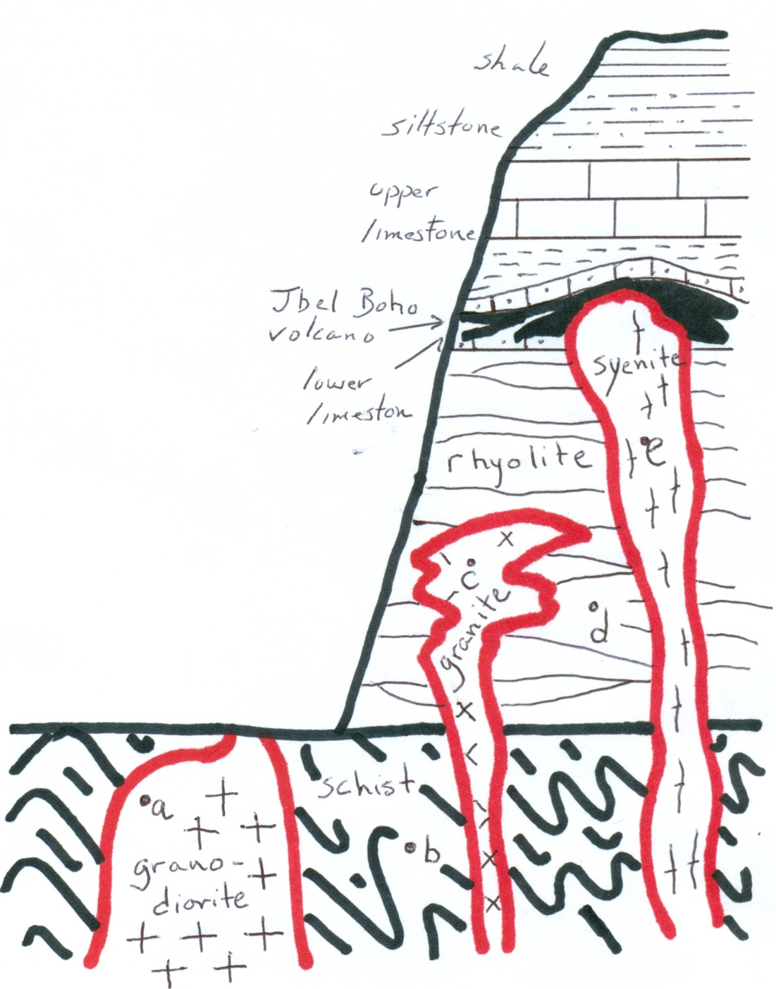

Below are data from the researchers determined in the 1970s. The radiometric age is the half-lived elapsed multiplied by the half-life. Calculate the radiometric ages and compare them to the sample locations.

sample | Method | Material | Half-life elapsed | Radiometric Age
a | U/Pb | zircons | 0.1366
b | Rb/Sr | whole rock, illite | 0.01276
c | U/Pb | zircons | 0.1251
d | U/Pb | zircons | 0.1284
e | U/Pb | zircons | 0.1186
The half-life for U/Pb is 4.5 billion years. The half-life for Rb/Sr is 48.8 billion years.
Do the radiometric ages agree or conflict with the field observations shown in the cross-section?
Cite specific examples.

Based on these data should the Cambrian-Precambrian boundary remain at 570 Ma? If yes, cite your evidence. If no, suggest a new age for the start of the Cambrian. Cite your evidence.

Lancelot, J.R., 1982, U-Pb dating of the Precambrian-Cambrian boundary in Morocco, p. 810-813, on Odin, G.S., ed., Numerical Dating in Stratigraphy, John Wiley & Sons, 1040 p.

