Exploring Mineral Properties Name__________________
GEO 111 Lab 3 – Winter 2012 – Riemersma Lab Section ________

This lab was written by Dr. Colgan, modified by Dr. Peterson and then modified alittle by myself. I developed the taconite pellet activity. See http://geology.csupomona.edu/alert/mineral/minerals.htm for more information and background on mineral identification and physical properties. Use the taconite activity on the last page of this lab as a "break" from mineral testing and identification.

Physical Properties of Minerals
Geologists can identify most minerals based on distinctive physical properties that can be easily measured in the field with very simple tools like a pen knife, a bottle of acid, a penny and a hand magnifier. A geologist must be able to recognize and correctly describe minerals in the field using the information that they have stored in their brains after years of looking a various rocks and minerals. Some minerals are very difficult to identify for even the most experienced geologists, so don’t feel bad if you find it difficult at first. Remember that developing your skills of observation and interpretation is more important right now than getting it right every time. Luckily, there are only about twenty common minerals and each of these minerals has only 2 to 3 important properties that must be remembered in order to identify the mineral. Very soon you will be able to recognize and describe the properties of the twenty most common minerals that make up the Earth.
Remember that a mineral is a naturally occurring, inorganic, crystalline solid, with a definite chemical composition that varies within limits, and specific properties that are consistent with a given range of temperatures and pressures. It is different from a rock which is an aggregate of one or more minerals. A mineral tends to be homogenous throughout its structure whereas a rock is typically heterogeneous.

Physical properties that geologists commonly use to identify minerals include:
color luster
streak cleavage or fracture
hardness crystal twinning (striations)
specific gravity magnetism
crystal form reaction to acid

Each mineral has certain diagnostic properties, which are the few physical properties that are more useful or distinctive in helping to certainly identify it. For example, the extreme hardness and brilliant luster of diamond are among its most diagnostic properties.

The purpose of this lab is to provide you with the opportunity to become familiar with these different physical properties and develop some skills in recognizing these properties in minerals. This week and throughout the semester you will use these skills to examine rocks.

We are more interested in your ability to identify minerals using their properties rather than "memorizing" what the different minerals and rocks look like. On your lab exam you will be asked to identify mineral properties as well as identify the name of the mineral or rock. Note that the initial 5 pages of this lab are focused on characterizing the properties of the minerals and we won't be focusing on identification of the minerals until page 10.

Mineral Color is one of the easiest properties for us to recognize because we are visual animals. The color of a mineral results from its chemical composition, but is also influenced by impurities or flaws in the mineral structure. For some minerals like sulfur (yellow) or malachite (green), color can be diagnostic. Unfortunately color is not always the most useful property for identifying minerals. Some colors, like white or black, are common to many minerals. Some minerals like quartz and diamonds can be almost any color depending on the types of impurities or imperfections in the crystal.

1. List the numbers of all the white or colorless minerals in your kit:

2. List the numbers of all the black or gray minerals in your kit:

3. List at least 3 minerals in your kit that have distinctive colors:

Sample # | Color(s)

Mineral Streak is the color of the powdered mineral. This is determined by scratching a mineral across a white ceramic “streak plate” (hardness = 6). The mineral is powdered by being ground on a white ceramic “streak” plate. If the mineral is harder than the ceramic plate then the streak can not be determined. Many of the silicates do not have a streak because they are harder than the streak plate. In some cases you may need to bear down fairly hard to get a streak, particularly if the mineral hardness is just a little less than the streak plate. If mineral specimens crumble or flake when powdered on the streak plate, it may help to blow away the excess to view the true streak color.

4. Specimens 7a and 7b have several similar properties to each other - both have a metallic luster (7b is dull metallic), both can be magnetic (7a weakly magnetic, 7b strongly magnetic), and both are dark in color. These two can be distinguished by their streaks (i.e. – streak is diagnostic)

 | Mineral Color | Streak Color
7a
7b

Mineral Luster describes how light is reflected from the surface of a mineral. There are two broad categories of luster, metallic and non-metallic. Minerals with a metallic luster have the shiny appearance of a metal and are opaque to light (think stainless steel, chrome, etc). Minerals with non-metallic luster may be shiny and transmit light (either transparent or translucent - although in some this may only be apparent along a thin edge) , or they can be dull, earthy, waxy, etc. Some mineral specimens do not fall neatly into metallic or sub-metallic categories either because the shiny surface of a metallic mineral is dulled by weathering or a non-metallic shiny mineral is too dark colored to tell if it is opaque or translucent. We typically refer to these as sub-metallic. Luster terms are descriptive and therefore somewhat subjective – see your book for a list and description of these terms. Vitreous describes a luster that is non-metallic and glassy. Brilliant or adamantine luster is reserved for minerals like diamond that sparkle and seem to throw out light.

5. In the table below
- List the numbers of 3 mineral specimens that have a metallic luster (first column)
- List the numbers of 3 that have a non-metallic luster (second column)
- List the numbers of the specimens for all of the specimens for which you are uncertain whether they have a metallic or non-metallic luster (third column)
- List the numbers of 2 specimens that have a vitreous (glassy) luster (4th column) – note these could be the same numbers as used in other columns.

Metallic Luster | Non-metallic Luster | Uncertain luster | Vitreous Luster

Mineral Hardness is a measure of the microscopic strength of the bonds between atoms in a mineral and is determined by its resistance to scratching. To communicate hardness we use the MOH's Scale of Hardness devised by Friedrich Mohs in 1812 (see your book). This is a relative scale in which minerals range from 1 (softest) to 10 (hardest). Mohs linked specific minerals of increasing hardness with the numbers from 1-10. Minerals with a higher number will scratch minerals with a lower number. Typically, geologists do not carry these 10 minerals around with them all of the time; instead we use common items of know hardness (see table below) to determine the relative hardness of unknown minerals.

Tool | Hardness
Fingernail | ~2.5
Copper penny | ~3
Glass plate | ~5.5
Streak plate | ~7.5

You will determine hardness by alternately using the different tools and mineral specimens to scratch each other to determine which is harder. You have to be very careful in determining if you are really scratching the mineral with the tool or if the tool can be scratched with the mineral. If two substances have very similar hardness's it can be quite difficult to determine which is doing the scratching (and this is a clue in itself).

Notice that the luster and color of specimens 1b and 12 are very similar and thus are not useful properties for distinguishing between these two minerals. A more diagnostic property for these two minerals is their hardness. One of these minerals should scratch glass and the other should not.

6. Circle the harder of these two minerals (the one that scratches glass). 1b or 12

7. Rank the following minerals according to their hardness: 3, 12, 14, 15a,

Hardest - ______ ______ ______ ______ - Softest

Mineral Cleavage and Fracture describe the way that a mineral breaks. Cleavage describes mineral breaks along nearly perfectly flat and smooth planes of weakness. Fracture describes mineral breaks along irregular surfaces. There are a number of descriptive terms for types of fracture. See separate Cleavage/Fracture sheet for more information.

Note that a mineral can break along a cleavage plane in one or more directions and fracture in others. Typically we describe the way a mineral breaks by identifying the number of different cleavage orientations/directions (0, 1, 2, 3,…) and if there is more than one cleavage direction we also specify the angle between the different cleavage plane directions (e.g. – perpendicular or non-perpendicular)

The following terms are used to describe common cleavage configurations, but if you cannot remember the terms it is also acceptable to specify the number and angle of the cleavage directions.

Type of breakage | Description | Illustration | Q#8 Sample
No cleavage | Fracture in all directions
Basal cleavage | one direction of cleavage (fracture in all other directions)
Prismatic cleavage | two directions at 90 degrees or at another angle
Cubic cleavage | three directions of cleavage perpendicular to one another – breaks into cubes | 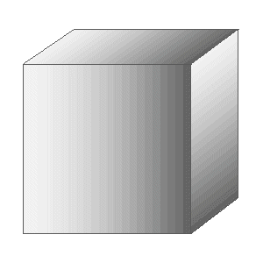
Rhombic cleavage | three directions of cleavage – not perpendicular (e.g. @ 60º and 120º) – breaks into rhomb shapes | 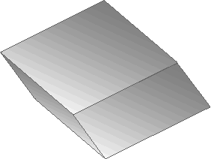
Octahedral cleavage | four directions of cleavage – breaks into octahedral shapes | 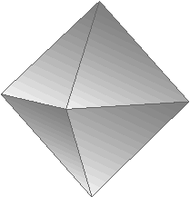

8. There are mineral cleavage/fracture sets at each table with samples (A-F). In addition a separate set is available on the counter along the side of the room with similar samples (for some) that you can break. (Do not break the specimens at your table). For each sample in the set, determine the breakage properties (cleavage and fracture) and match each sample to the breakage properties described in the table above by writing its letter in the sample column in the table above at right.

Crystal form is the shape in which the crystal grows if it has enough space to develop. These are the forms we associate with spectacular examples of minerals in museums. Some minerals have a very distinctive crystal form. Most of the flat surfaces you see in lab are not crystal faces, but instead cleavage planes. If you aren’t sure if it’s a cleavage plane or crystal face then ask your instructor. Examples include the hexagonal pyramid of some quartz crystals. Halite, pyrite, and galena have a cubic crystal form sometimes. The following samples in your kit are examples of crystal form:

Sample # | Crystal forms
3a | hexagonal
10 | dodecahedral
11 | cubic
13 | cubic

9. Compare these crystal forms to samples with known cleavage surfaces. Describe one strategy for distinguishing flat shiny surfaces produced by crystal growth (i.e. - crystal form) from flat shiny surfaces produced by breaking the mineral (cleavage surfaces).

Feldspars and Striations
The most common rock forming mineral in the earth's crust is the feldspar group of minerals (1a & 1b). There are two common varieties of feldspar that you will need to be able to identify, plagioclase (calcium or sodium feldspar) and orthoclase (potassium feldspar). Orthoclase is commonly referred to as K-feldspar and is commonly, but not consistently pink. An important difference between the Ca-rich and Na-rich varieties of plagioclase is that sodium-rich varieties are white to light-colored and calcium-rich varieties can be much darker (the most Ca-rich are typically dark gray)
The feldspars share several common physical properties due to similarities in their structure and composition. All the feldspars are slightly harder than glass and have two directions of cleavage (prismatic cleavage) that are nearly perpendicular. It can be difficult to distinguish orthoclase from plagioclase feldspars in hand sample. Twinning striations can be a useful diagnostic property in distinguishing between these two feldspar groups. Striations appear as very straight, very fine parallel grooves on one cleavage surface (note - there are striations on your fingernails). To find striations turn specimen so that light is reflecting off the cleavage surface. Striations appear on the cleavage surface and do not visibly penetrate into the sample. Beginning mineralogists may confuse striations with a feature often present in K-feldspar called exsolution. Exsolution forms as the feldspar grain separates into lamellae of slightly different compositions while it is forming. Exsolution commonly looks like fine irregular bands of slightly different color.

10. There is a feldspar station in the front of the room with two samples (A and B). One of these samples has striations and one has exsolution. Determine which is which.

Which sample (A or B) has striations?
Which sample (A or B) has exsolution?
Specific Gravity is measure of the density of a mineral compared to the density of water (which has a density of 1 gram/cm³). Remember that density is a measure of a mass of a substance relative to its volume (mass/volume) Specific gravity is given as a ratio - a mineral with a specific gravity of 4.3 means that it is 4.3 times as dense as water. Most common crustal minerals have a specific gravity in the range of ~2.65-2.8 (note that this is comparable to the density of continental crust). A few minerals deviate from this range (either higher or lower) enough so that we can detect a difference in their “heft”, even in small hand samples.

11. Compare the “heft” of the minerals in your box. In the spaces below, list any minerals (by sample number) which you think have a high specific gravity and any that you think have a low specific gravity.
High - Low -

Other useful but less common properties

Reaction to Dilute Acid (HCL)
There are two minerals that we will be studying this semester that react to acid, calcite and dolomite. Calcite will react quickly to acid, dolomite will react slowly to acid and usually needs to be powdered to react. Only calcite is in your mineral sets.

12. Which specimen is calcite?
(to avoid squirting acid on every specimen, note that calcite is non-metallic and has good cleavage)

Magnetism
13. A few minerals are attracted to a magnet. These are minerals that contain iron (Fe) in their structure. Which samples in your box are either weakly or strongly magnetic? (list the numbers)

Feel
14. There is one mineral at a Feeling station at the side of the room. Describe how this sample feels to the touch. What do you think this is?

Taste
I do not recommend this in the lab where many students have handled and probably dropped acid on the samples, but taste can be a quick diagnostic property of salty minerals like halite.

Mineral Identification

As you have just discovered, all minerals have various physical properties such as hardness, cleavage, luster and color as examples. These physical properties are a direct result of the chemistry of the mineral and how the atoms are bonded together.

One key to identifying minerals in hand specimen is to remember the most IMPORTANT properties for each mineral. This means that for most minerals you can identify them by memorizing 2 to 3 distinctive properties for each mineral.

To begin identifying your minerals for the first time use the keys that I put out on each table. To use the keys follow the steps below:

Step 1 – Determine the luster of the mineral (metallic or non-metallic)
Step 2 – Determine the hardness of the mineral.
Step 3 – Determine the cleavage or fracture of the mineral.
Step 4 – Determine the color and other special properties.
Step 5 – Make a guess at the mineral name and then check for other properties to help you decide if you are correct.

The second key to identifying minerals is to remember some general hints and associations of the mineral groups to their properties.

- The hardest minerals are usually silicate minerals.
- Felsic silicates are usually white, pink, or light purple.
- Mafic silicates are usually black, gray, or green.
- Ore minerals commonly have unusual lusters (metallic), colored streaks, or high specific gravities.
- Calcite fizzes when dilute HCL is put on it.
- Quartz can have many different colors.
- Some minerals will not follow these general rules.

After you have learned the names of all the minerals go back and study them each time you are in lab and a few minutes each day. Remember the important properties for each mineral and you should be able to identify all of them on a practical exam.

Assignment:

Complete the following mineral identification resource sheets by filling in all the information about each mineral. Use the information you have already collected about mineral properties. These sheets will serve as a reference for you in learning these minerals. Don't forget to answer the questions also!
The Silicate Group of Minerals
In the space below each pair of minerals indicate the property that best helped you to distinguish between them:

Sample #1a |  |  | Sample #1b
Luster |  |  | Luster
Hardness |  |  | Hardness
Fracture or cleavage |  |  | Fracture or cleavage
Color(s)/streak |  |  | Color(s)/streak
Specific gravity |  |  | Specific gravity
Special Properties |  |  | Special Properties
Chemical Formula |  |  | Chemical Formula
Mineral Name |  |  | Mineral Name
What property best helps you distinguish between 1a & 1b?

Sample #3a  (note 3b is same mineral w/ crystal faces) |  |  | Sample #15b
Luster |  |  | Luster
Hardness |  |  | Hardness
Fracture or cleavage |  |  | Fracture or cleavage
Color(s)/streak |  |  | Color(s)/streak
Specific gravity |  |  | Specific gravity
Special Properties |  |  | Special Properties
Chemical Formula |  |  | Chemical Formula
Mineral Name |  |  | Mineral Name
What property best helps you distinguish between 3 & 15b?

Sample #6a |  |  | Sample #6b
Luster |  |  | Luster
Hardness |  |  | Hardness
Fracture or cleavage |  |  | Fracture or cleavage
Color(s)/streak |  |  | Color(s)/streak
Specific gravity |  |  | Specific gravity
Special Properties |  |  | Special Properties
Chemical Formula |  |  | Chemical Formula
Mineral Name |  |  | Mineral Name
What property best helps you distinguish between 6a & 6b?

Sample #8a |  |  | Sample #8b
Luster |  |  | Luster
Hardness |  |  | Hardness
Fracture or cleavage |  |  | Fracture or cleavage
Color(s)/streak |  |  | Color(s)/streak
Specific gravity |  |  | Specific gravity
Special Properties |  |  | Special Properties
Chemical Formula |  |  | Chemical Formula
Mineral Name |  |  | Mineral Name
What property best helps you distinguish between 8a & 8b?

Sample #9 |  |  | Sample #10
Luster |  |  | Luster
Hardness |  |  | Hardness
Fracture or cleavage |  |  | Fracture or cleavage
Color(s)/streak |  |  | Color(s)/streak
Specific gravity |  |  | Specific gravity
Special Properties |  |  | Special Properties
Chemical Formula |  |  | Chemical Formula
Mineral Name |  |  | Mineral Name
What property best helps you distinguish between 9 & 10?

A Native Element and Ore Minerals

Sample #2 |  |  | Sample #11
Luster |  |  | Luster
Hardness |  |  | Hardness
Fracture or cleavage |  |  | Fracture or cleavage
Color(s)/streak |  |  | Color(s)/streak
Specific gravity |  |  | Specific gravity
Special Properties |  |  | Special Properties
Chemical Formula |  |  | Chemical Formula
Mineral Name |  |  | Mineral Name
What property best helps you distinguish between 2 & 11?

Sample #5a |  |  | Sample #5b
Luster |  |  | Luster
Hardness |  |  | Hardness
Fracture or cleavage |  |  | Fracture or cleavage
Color(s)/streak |  |  | Color(s)/streak
Specific gravity |  |  | Specific gravity
Special Properties |  |  | Special Properties
Chemical Formula |  |  | Chemical Formula
Mineral Name |  |  | Mineral Name
What property best helps you distinguish between 5a & 5b?

Sample #7a |  |  | Sample #7b
Luster |  |  | Luster
Hardness |  |  | Hardness
Fracture or cleavage |  |  | Fracture or cleavage
Color(s)/streak |  |  | Color(s)/streak
Specific gravity |  |  | Specific gravity
Special Properties |  |  | Special Properties
Chemical Formula |  |  | Chemical Formula
Mineral Name |  |  | Mineral Name
What property best helps you distinguish between 2 & 11?

Samples 5b, 7b, and 11 are common ore minerals – For which element are each mined? (look at the chemical formula)

Sample # | Mineral Name | Element mined
5b:
7b:
11:

Examples From Other Mineral Groups

Sample #12 |  |  | Sample #13
Luster |  |  | Luster
Hardness |  |  | Hardness
Fracture or cleavage |  |  | Fracture or cleavage
Color(s)/streak |  |  | Color(s)/streak
Specific gravity |  |  | Specific gravity
Special Properties |  |  | Special Properties
Chemical Formula |  |  | Chemical Formula
Mineral Name |  |  | Mineral Name

Sample #14 |  |  | Sample #15a
Luster |  |  | Luster
Hardness |  |  | Hardness
Fracture or cleavage |  |  | Fracture or cleavage
Color(s)/streak |  |  | Color(s)/streak
Specific gravity |  |  | Specific gravity
Special Properties |  |  | Special Properties
Chemical Formula |  |  | Chemical Formula
Mineral Name |  |  | Mineral Name

For each of these 4 samples, name one property that best distinguishes it from the rest:

Sample # | Mineral Name | Most distinguishing property
12
13
14
15a

Banded Iron Formation, Iron Ore and Taconite Pellets

In the United States, Michigan and Minnesota produce about 95% of the iron ore mined in the United States. The rock being mined is a 2.25 billion year old banded iron formation, a unique sedimentary rock that consists of alternating layers of red, silica rich jasper and gray-black iron oxide minerals hematite/magnetite (Figure 1). One explanation for how the iron oxide layers were deposited involves an ocean rich in dissolved iron and lacking dissolved oxygen. The development of photosynthetic life introduced dissolved oxygen into the ocean waters, oxygen that then caused dissolved iron to precipitate out as Fe₂O₃ or Fe₃O₄ (Figure 2 below).
Most of this iron ore is used to make steel. Until 1955, only natural "direct shipping" ores were mined. These ores had a high percentage of iron minerals like hematite and magnetite because silica rich minerals like chert had been weathered and leached out of the rock. After 1955 technology was developed to profitably mine lower grade unaltered "taconite" ore and manufacture concentrated taconite pellets (Figure 3).

B-1 The Edmund Fitzgerald sank on Lake Superior on Nov 10, 1975, carrying a full load of taconite pellets weighing 26,000 long tons. Given that 1 long ton is 1,016 kg, (and 1000 grams = 1 kg) how many taconite pellets were lost in the sinking (and are still down there)? Show your calculations.

First weigh at least 10 taconite pellets and then calculate how much an average taconite pellet weighs in grams.
Number of pellets _______Weight _______ ________________
Average mass of one taconite pellet in grams______________________

Number of taconite pellets that went down with the Fitz _______________________

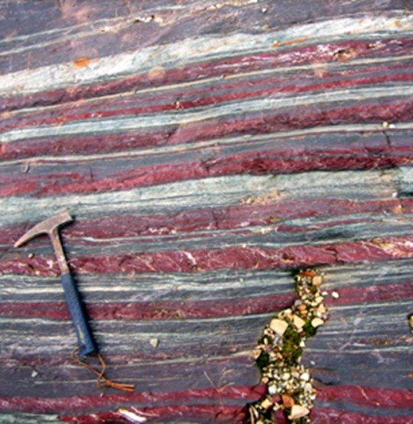
Figure 1. Layering of red jasper and
grey iron oxides in BIF

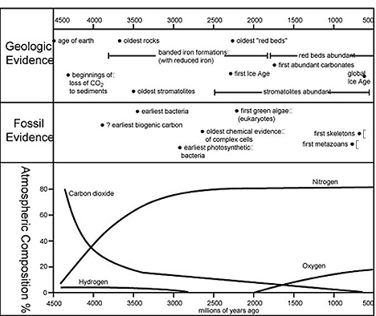

Figure 2 BIFs and atmospheric oxygen.
http://rst.gsfc.nasa.gov/Sect19/Sect19_2a.html

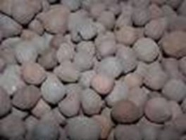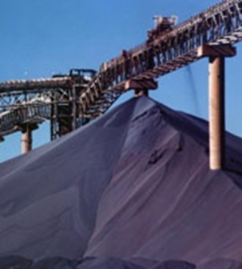
Figure 3 Taconite Pellets.

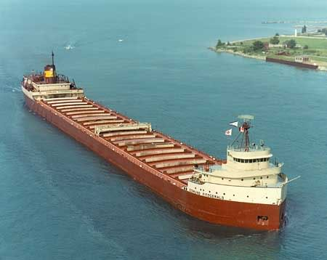
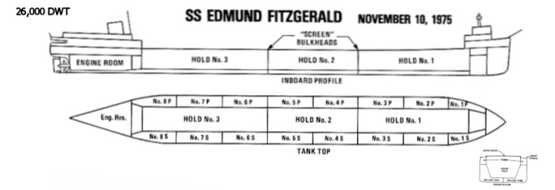

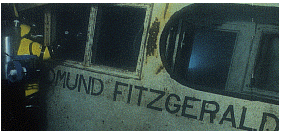

Edmund Fitzgerald

