MICHIGAN GEOLOGICAL HISTORY | Friday, July 20
45 min assessment  Engage  Bedrock map of Michigan  9:30 lv for Napoleon  10-11 am Napoleon – field trip  11-12 drive to Grand Ledge  1-3 pm Grand Ledge – field trip  Michigan’s Ride on North American plate  Materials  Virtual Isochron  3-4 pm Discussion  Field Course Formative assessment | Big Idea = 4. Earth is continuously changing.  Connect to UP trip, unconformity, artesian aquifers  Sloss sequences  Changes in NA plate over time  Make jigsaw map  Misconceptions  Put in order: major events, rocks

Future • Develop a simple jigsaw map for time/space.
Future • Visit “new” “red bed” exposures near Ionia.
Have • __ copies of the bedrock map of Michigan.
Done •rewrite Michigan’s Ride on North American plate
Potential geocache site: Grand Ledge x 3 or Napoleon

Need:
Text; Geology of Michigan, p. 54-58
Bed Rock Map of Michigan (might look at before/after the drive)
Maps, camera, handouts, Google maps of area

How do the sedimentary rock layers in Michigan reflect Earth history?

EarthComm: Understanding our Environment, Activity 1, p. 11-45

We have a rich website on Grand Ledge at:
http://www.geo.mtu.edu/~raman/SilverI/MiTEP_ESI-2/Day_10_Grand_Ledge.html

The link to the Geocache esker near Lansing Called "Dewitt to Mason":
http://www.geocaching.com/seek/cache_details.aspx?wp=GC12RVX

The writer of the earthcache gives us mutliple locations to view the esker (as well as mutliple examples for us to 'prove' that we have visited the sites. You need to create a free account in order to see the first coordinates (N 42° 30.560 W 084° 21.587 UTM: 16T E 716910 N 4709707), the others are listed near the bottom of the page. It seems that part of the esker may reach the east part of Lansing.
EXPLORING THE ROCKS OF THE JACKSON AREA
The bedrock map of Michigan shows the distribution of rock types across the state. The Stratigraphic Section of Michigan shows the general layers of rocks a geologist would find if she drilled a hole down several miles from the center part of the Lower Peninsula. Use the bedrock map of Michigan and the Stratigraphic Section of Michigan to answer the following questions.

On the bedrock map:
1. Find Jackson County.
2. Notice the colored bands that traverse across the county. These colored bands represent the rock units in our area.

How many colored bands are in the county? _______

3. The map legend is along the right hand side of the map. The legend matches the colored bands to the names for the rocks that geologists use. The youngest rocks are at the top of the legend. The oldest rocks are at the bottom of the legend.

Match the colored bands to the names of the geologic units:

Top (youngest rocks ): 1. __________________ (northwest corner of county)
2. __________________
3. __________________
4. __________________
Bottom (oldest rocks): 5. __________________ (southeast corner of the county)

On the Stratigraphic Section of Michigan:
4. Look for the geologic units you listed in question 3 near the top of the stratigraphic section. Geologists use specific symbols to designate specific rock types. The “EXPLANATION” on the bottom right of the page shows the rock types (limestone, dolomite, shale, etc…). Use the EXPLANATION to identify the rock types in Jackson County. Use the information to complete the table below:

Geologic Units | Rock Type
1.
2. | limestone
3.
4. Marshall Sandstone
5.
5. What two rocks are the most common in Jackson County?

6. Have another look at the stratigraphic section. For rock layers below those in Jackson County (lower in the section, older), what is the most common rock? Is this the same or different than Kalamazoo County?
EXPLORING THE ROCKS OF THE KENT COUNTY
The bedrock map of Michigan shows the distribution of rock types across the state. The Stratigraphic Section of Michigan shows the general layers of rocks a geologist would find if she drilled a hole down several miles from the center part of the Lower Peninsula. Use the bedrock map of Michigan and the Stratigraphic Section of Michigan to answer the following questions.

On the bedrock map:
1. Find Kent County.
2. Notice the colored bands that traverse across the county. These colored bands represent the rock units in our area.

How many colored bands are in the county? _______

3. The map legend is along the right hand side of the map. The legend matches the colored bands to the names for the rocks that geologists use. The youngest rocks are at the top of the legend. The oldest rocks are at the bottom of the legend.

Match the colored bands to the names of the geologic units:

Top (youngest rocks ): 1. __________________ (northeast corner of county)
2. __________________
3. __________________
4. __________________
Bottom (oldest rocks): 5. __________________ (southwest corner of the county)

On the Stratigraphic Section of Michigan:
4. Look for the geologic units you listed in question 3 near the top of the stratigraphic section. Geologists use specific symbols to designate specific rock types. The “EXPLANATION” on the bottom right of the page shows the rock types (limestone, dolomite, shale, etc…). Use the EXPLANATION to identify the rock types in Kent County. Use the information to complete the table below:

Geologic Units | Rock Type
1.
2.
3. | limestone
4.
5. Marshall Sandstone
5. What two rocks are the most common in Kent County?

6. Have another look at the stratigraphic section. For rock layers below those in Kent County (lower in the section, older), what is the most common rock?

EXPLORING THE ROCKS OF THE KALAMAZOO AREA
The bedrock map of Michigan shows the distribution of rock types across the state. The Stratigraphic Section of Michigan shows the general layers of rocks a geologist would find if she drilled a hole down several miles from the center part of the Lower Peninsula. Use the bedrock map of Michigan and the Stratigraphic Section of Michigan to answer the following questions.

On the bedrock map:
1. Find Kalamazoo County.
2. Notice the colored bands that traverse across the county. These colored bands represent the rock units in our area.

How many colored bands are in the county? _______

3. The map legend is along the right hand side of the map. The legend matches the colored bands to the names for the rocks that geologists use. The youngest rocks are at the top of the legend. The oldest rocks are at the bottom of the legend.

Match the colored bands to the names of the geologic units:

Top (youngest rocks ): 1. __________________ (northeast corner of county)
Bottom (oldest rocks): 2. __________________ (southwest corner of the county)

On the Stratigraphic Section of Michigan:
4. Look for the geologic units you listed in question 3 near the top of the stratigraphic section. Geologists use specific symbols to designate specific rock types. The “EXPLANATION” on the bottom right of the page shows the rock types (limestone, dolomite, shale, etc…). Use the EXPLANATION to identify the rock types in Kalamazoo County. Use the information to complete the table below:

Geologic Units | Rock Type
1.
2.

5. What two rocks are the most common in Kalamazoo County?

6. Have another look at the stratigraphic section. For rock layers below those in Kalamazoo County (lower in the section, older), what is the most common rock? Is this the same or different than Jackson County?

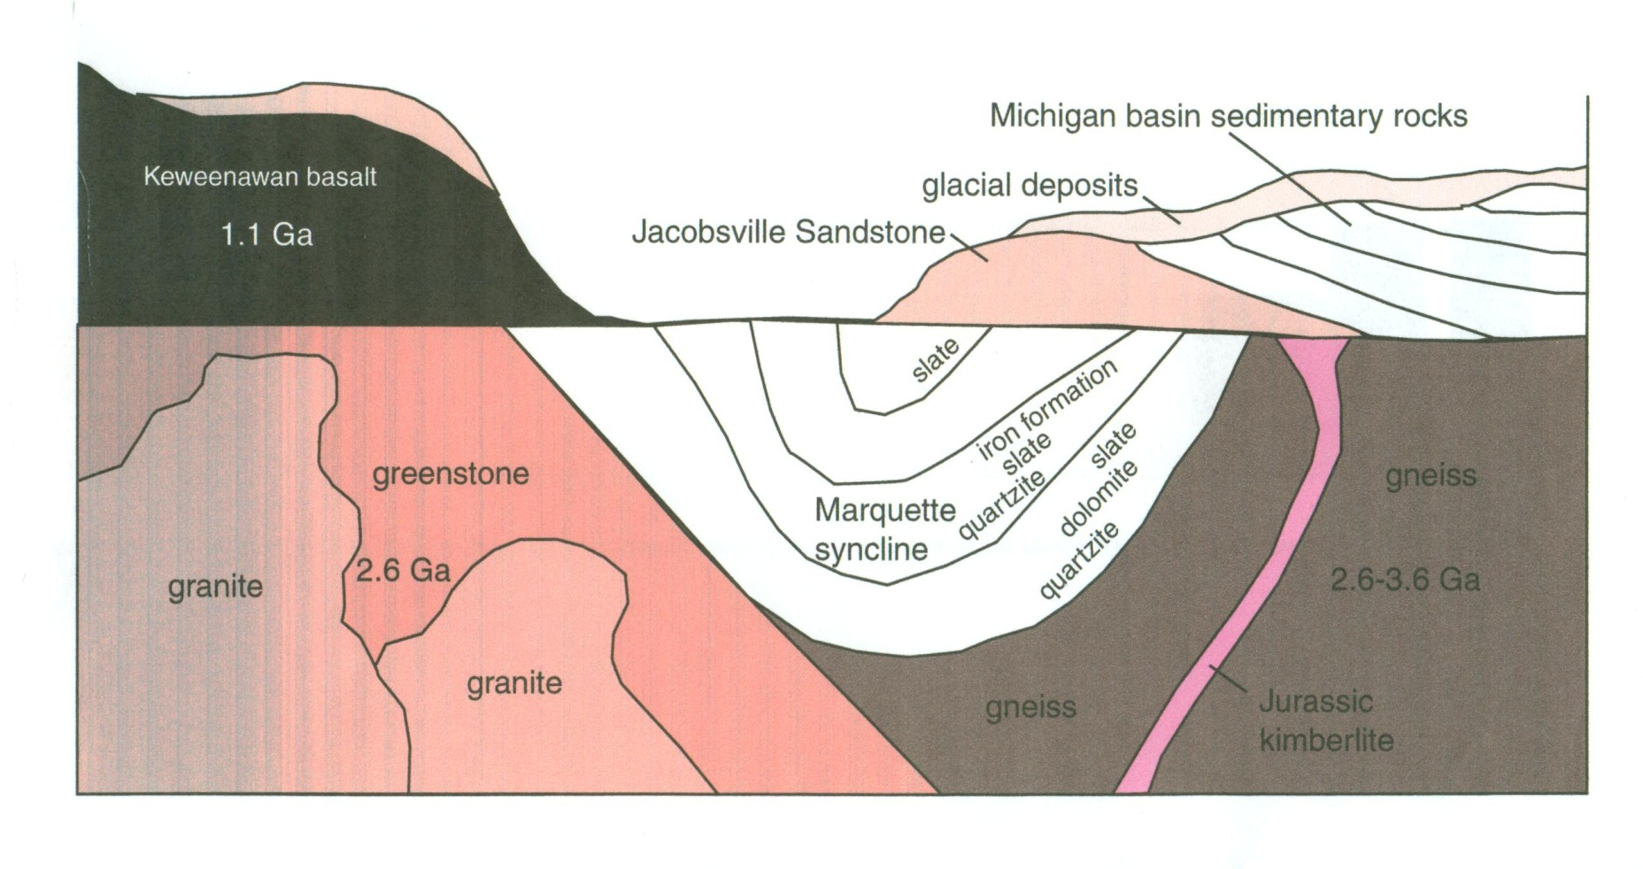

ESI 2 Friday, 7/20/2012 Assignment

Directions: Answer the following questions in your field notebook.

Today will focus on the geologic history and rocks of Michigan.
1. Which rocks are older, those at Napoleon or Grand Ledge? Describe the evidence.

- Describe the general geologic history of Michigan in 10-15 steps/events. The cross-section might help.

- Place these rocks in order from 1-10 with 1 as the oldest:

_____ striated cobble
_____ Petosky stone
_____ Jacobsville Sandstone
_____ BIF at Jasper Knob
_____ rift basalts
_____ stromatolites at Horseshoe Harbor
_____ coal at Grand Ledge
_____ sandstone at Pictured Rocks
_____ greenstones near Marquette
_____ limestone at Castle Rock
_____ Napoleon Sandstone

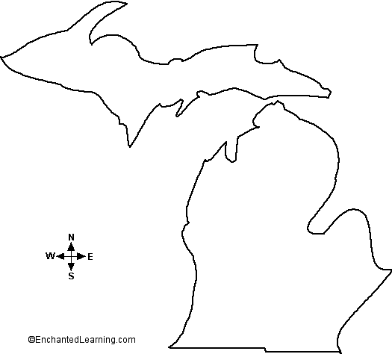

ESI 2 Friday, 7/20/2012 Assignment

Directions: Answer the following questions in your field notebook.

Today will focus on the geologic history and rocks of Michigan.
1. Which rocks are older, those at Napoleon or Grand Ledge? Describe the evidence.

- Describe the general geologic history of Michigan in 10-15 steps/events. The cross-section might help.

- Place these rocks in order from 1-10 with 1 as the oldest:

_____ striated cobble
_____ Petosky stone
_____ Jacobsville Sandstone
_____ BIF at Jasper Knob
_____ rift basalts
_____ stromatolites at Horseshoe Harbor
_____ coal at Grand Ledge
_____ sandstone at Pictured Rocks
_____ greenstones near Marquette
_____ limestone at Castle Rock
_____ Napoleon Sandstone

ESI 2 Friday, 7/20/2012 Assignment

Directions: Answer the following questions in your field notebook.

Today will focus on the geologic history and rocks of Michigan.
1. Which rocks are older, those at Napoleon or Grand Ledge? Describe the evidence.

- Describe the general geologic history of Michigan in 10-15 steps/events. The cross-section might help.

- Place these rocks in order from 1-10 with 1 as the oldest:

_____ striated cobble
_____ Petosky stone
_____ Jacobsville Sandstone
_____ BIF at Jasper Knob
_____ rift basalts
_____ stromatolites at Horseshoe Harbor
_____ coal at Grand Ledge
_____ sandstone at Pictured Rocks
_____ greenstones near Marquette
_____ limestone at Castle Rock
_____ Napoleon Sandstone

Today will focus on the geologic history and rocks of Michigan.
- Describe the general geologic history of Michigan in 10-15 steps/events. The cross-section might help.

- Place these rocks in order from 1-10 with 1 as the oldest:

_____ striated cobble
_____ Petosky stone
_____ Jacobsville Sandstone
_____ BIF at Jasper Knob
_____ rift basalts
_____ stromatolites at Horseshoe Harbor
_____ coal at Grand Ledge
_____ sandstone at Pictured Rocks
_____ greenstones near Marquette
_____ limestone at Castle Rock
_____ Napoleon Sandstone

