Groundwater

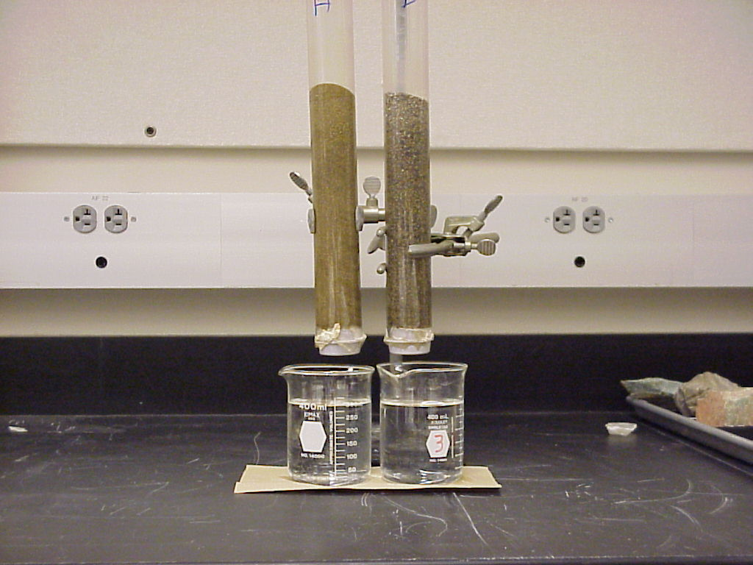
Engage: Movement of water through geologic materials.
The two columns consist of:
a. fine sand (left) b. coarse sand (right)
Which of these columns has the most open space between particles?
Which of these columns will allow the most water to pass through it in the shortest time?

Pour 300 ml of water in each column. Note the time. Complete the table below.

Column | Amount recovered:  1 minute | Amount recovered:  2 minutes | Amount recovered:  5 minutes | Amount recovered:  10 minutes
a. fine sand
b. coarse sand

What geologic material is most efficient at allowing water to pass through it?
What geologic material is least efficient at allowing water to pass through it?
Describe the general relationship between the size of material and the ability to transmit water.
Was all the water recovered? Where is the “missing” water?
Explore:
1. Finding Water
The figure on the next page is a map of aquifers, water-bearing units, of Michigan. Each aquifer is shown in a different color. Use the map legend below to identify each aquifer in Marquette County.

a. ___________________________
b. ___________________________
c. ___________________________
d. ___________________________

For each of the aquifers that you identified above determine the common types of rocks it contains (shale, limestone, sandstone, etc.). You will need to use the hydrogeologic units chart.

a. ___________________________
b. ___________________________
c. ___________________________
d. ___________________________

Aquicludes are rock units that do not permit water to flow thorough them. They are also called confining units because confine the water to water-rich aquifer layers.
Use the stratigraphic column to identify the confining units in Marquette County.
What rock type is most common as an aquiclude? (shale, limestone, sandstone, dolostone, etc.). Circle your answer.

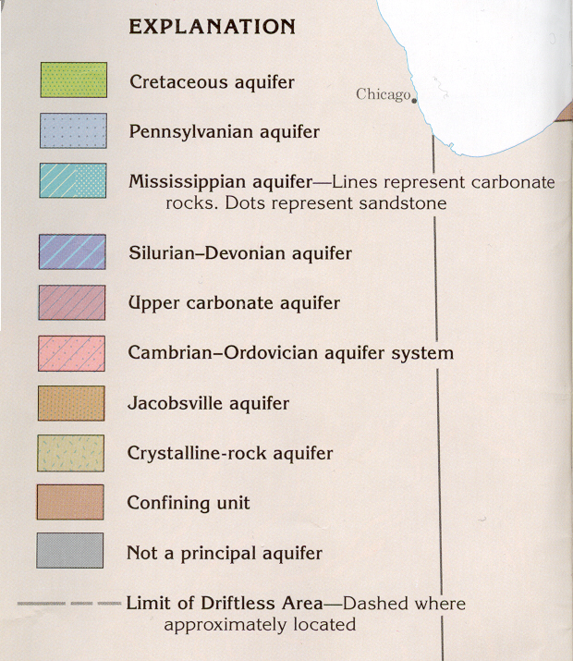
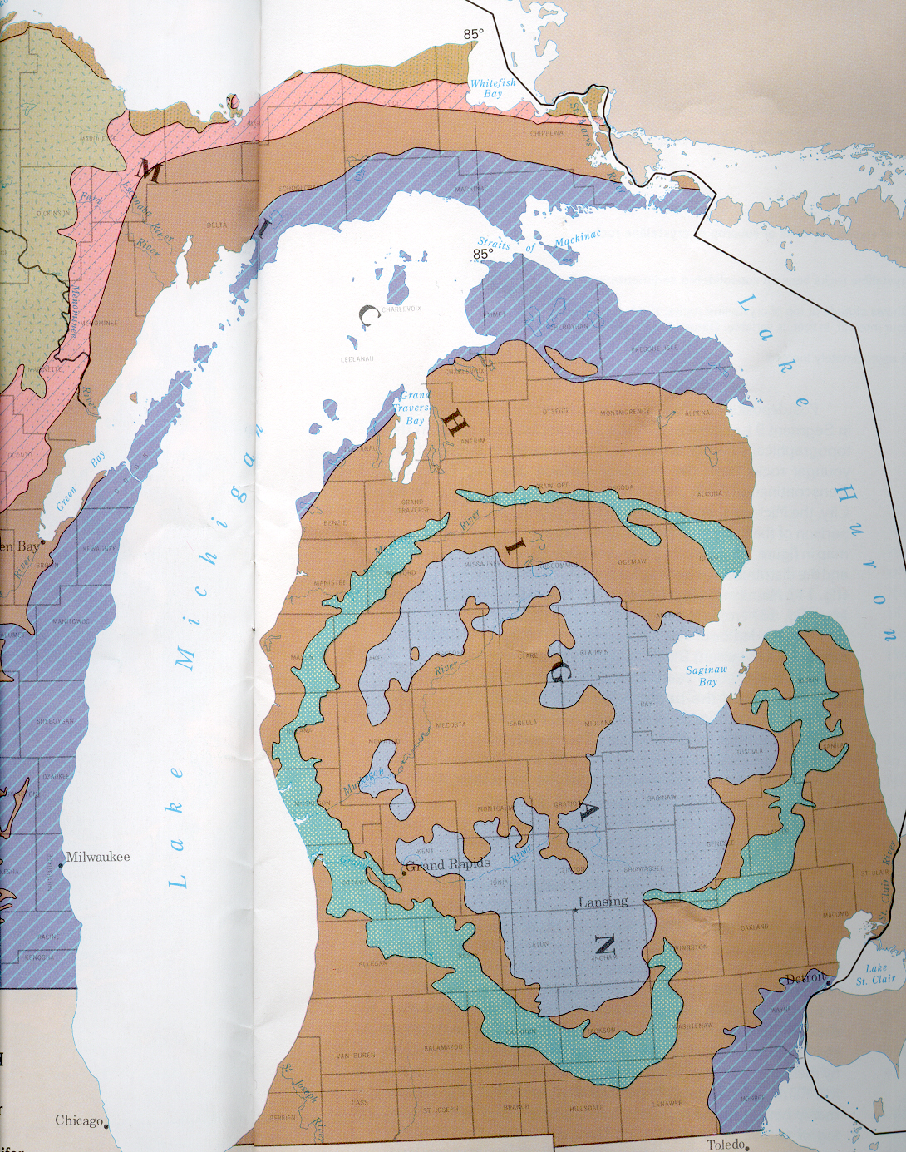
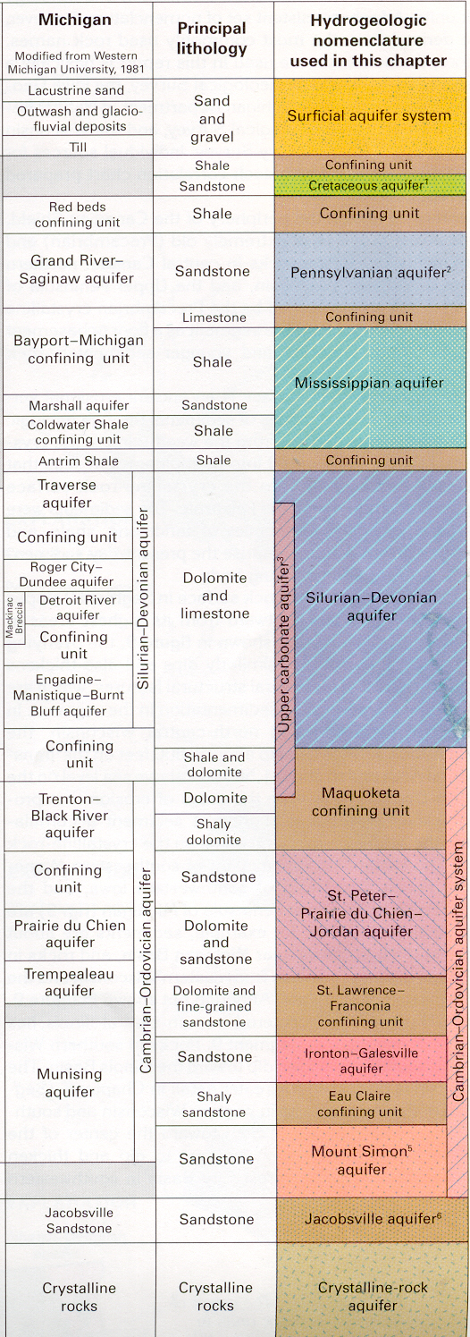
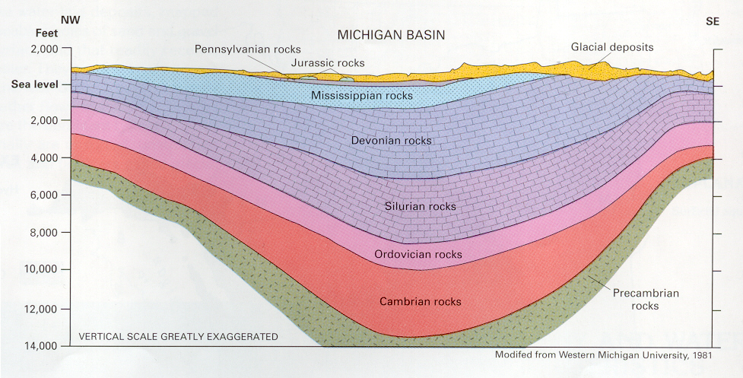
This figure shows a cross-section of the aquifers in the Michigan Basin.
In general what direction do the layers slope from Marquette County to the center of the Lower Peninsula?
In what direction does the groundwater flow?
How do the rocks in this cross-section relate to the rocks in Marquette County? (Refer to the lesson on Rocks of Michigan if needed).

2. Where does the water in Marquette County come from?
Visit the EPA’s Watershed page (http://cfpub.epa.gov/surf/locate/countyperstate_search.cfm?statepostal=MI) and click on Marquette County. Click on one of the basins in Marquette County.
a. What is the name of the basin?
b. What are the main aquifers?
c. What geologic material is the aquifer made of?

Return to the web page and click on the following:
(Water use (1990): Information about the amount of water used and how it is used)
Answer the following questions.
d. Is more groundwater or surface water used in this basin?
e. List the uses of groundwater in this basin.

3. Water movement in shallow aquifers.
Geologists have identified two different kinds of aquifers. One is common in the glacial materials that blanket the surface in Michigan. The other is found in the rock layers at greater depths (as shown in the rock stratigraphic columns).

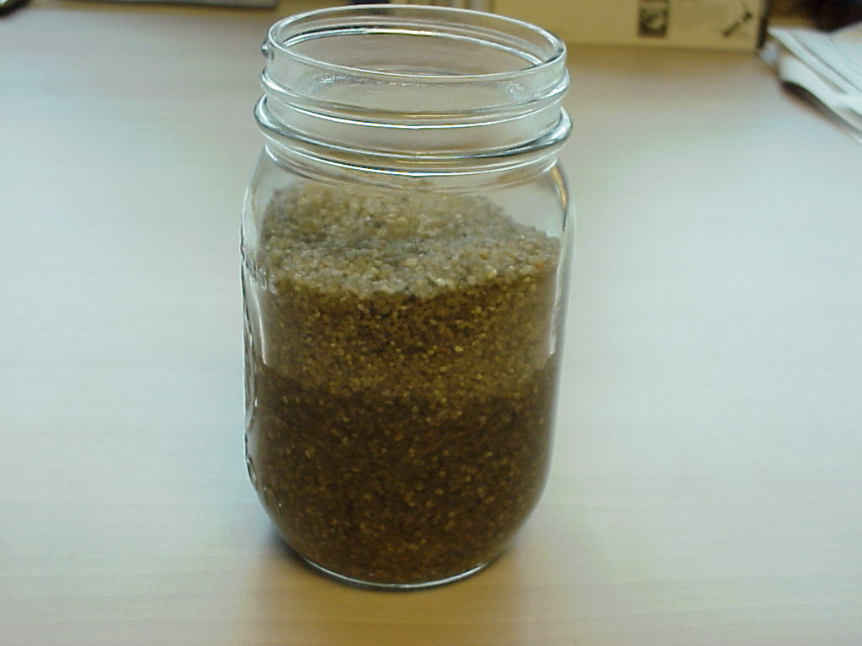
This jar of sand is a simple model for one of the most important types of aquifers in Michigan.
1. What holds the sand in place (what confines the sand)?
2. Is the pore space between the sand grains they same everywhere in the jar? Describe any differences.
3. What factors influence the water level in the jar?
4. If you “drilled” into the sand with a straw how deep would you need to go to reach the aquifer?
5. Geologists call the boundary between water filled pores and air filled pores the water table. Indicate on the jar where the water table is in this simple system.

4. Water movement in deep aquifers.
The diagram below shows a cross-section of a deep aquifer. The water-bearing layer is sandwiched between two impermeable layers (layers that don’t let water through), commonly shale. The water might be in a sandstone.
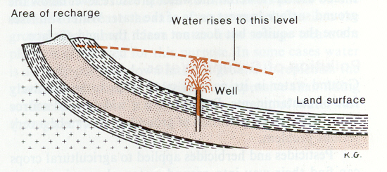
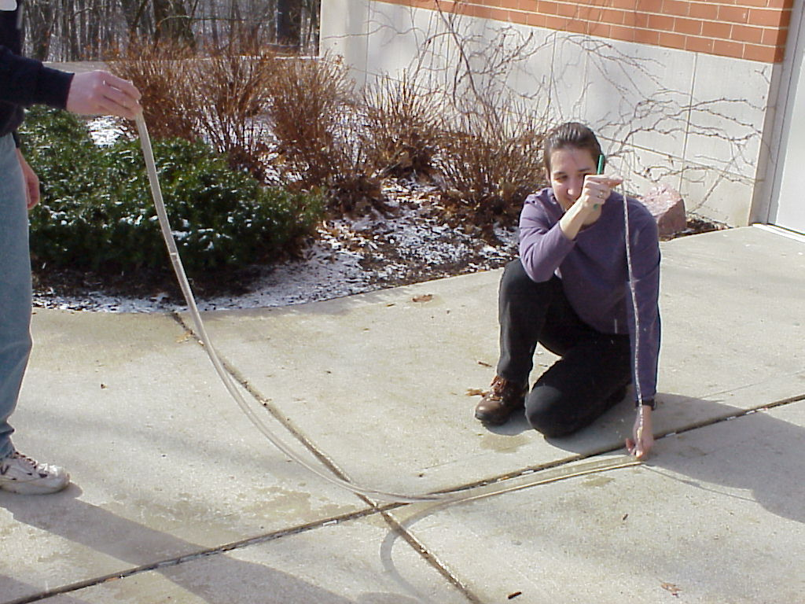
Set up a model of a deep aquifer as shown above. The walls of the plastic tube represent aquicludes like clay or shale. The open tube represents the confined permeable layer that contains water, a sandstone. Pour water into the model until about half full.

1. Elevate the end of the thick tube that represents the open end of the aquifer.
Does the level of the water in the well (thin vertical tube) increase or decrease?
2. Repeat by lowering the open end of the tube. Does the level of the water in the well increase or decrease?
3. Can you raise the tube to make water flow out of the well? Describe the conditions (make a drawing if needed).
4. What is the major influence on the level of the water in the well?
5. For real aquifers how do you think water is added to permeable rock layers?

Explain:
Porosity and permeability are two important characteristics in rocks that influence how water moves through them. Porosity is the percentage of a rock’s volume that is taken up by openings. Permeability is the capacity of a rock to transmit water. For example, sand, gravel, sandstone, and cavernous limestone have high porosity and permeability. They make good aquifers. Glacial till, clay, granite, metamorphic rocks, and shale have lower porosity and permeability and tend to make aquicludes.

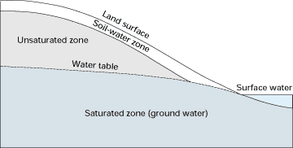
The water table is the upper surface of the saturated zone (the zone where spaces between grains are filled with water). The water table meets bodies of water at the surface at lakes and rivers. Diagram courtesy of U.S. Geological Survey (Circular 1139).

Aquifers are bodies of saturated rock or sediment through which water can move readily. Aquicludes are bodies of rock or sediment that do not allow water to move readily through them.

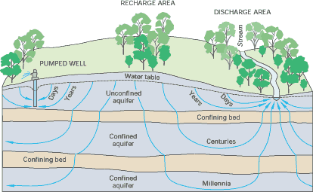
The slope of the watertable tends to follow the slope of the land surface. In an unconfined aquifer flow paths are shallow arcs that move the water towards rivers and lakes. Water in confined aquifers can also take curved paths that eventually (after centuries of years) reach the surface. Diagram courtesy of U.S. Geological Survey (Circular 1139).
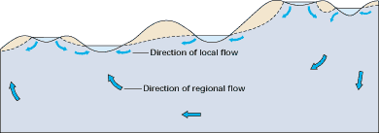
Typical groundwater flows paths in glacial and dune areas. Note that lakes and wetlands at higher elevations recharge the groundwater at lower elevations. The source of water in an unconfined aquifer is rainfall. Rainfall is also the source of water in confined aquifers. Diagram courtesy of U.S. Geological Survey (Circular 1139).

Humans can influence aquifers in many ways.

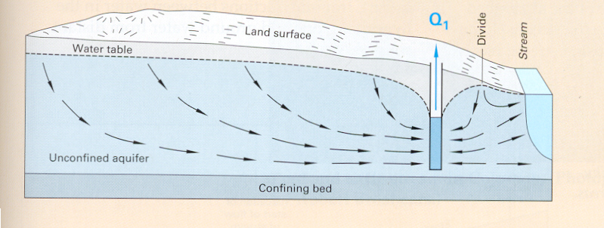
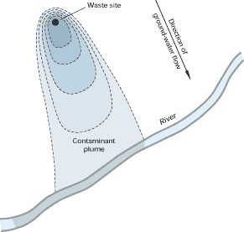
Overpumping of water causes the surface of the water table to be lowered adjacent to wells. In three dimensions, the water table forms a funnel-shaped feature called a cone of depression. In some cases the cone of depression can cause the local groundwater to change flow direction. Diagram courtesy of U.S. Geological Survey (Circular 1139).

Contamination of aquifers can occur when pollutants seep into the groundwater. These pollutants can be from point sources (leakage from underground storage tanks, sewage plants) or nonpoint sources (fertilizers, pesticides). Diagram courtesy of U.S. Geological Survey (Circular 1139).
Apply:
1. Finding Water In Your County.
Return to the maps and figure in Explore 1.
How many aquifers are there in your county? Each aquifer is shown in a different color. Use the map legend to identify each aquifer in your county.

a. ___________________________
b. ___________________________
c. ___________________________
d. ___________________________
e. ___________________________

For each of the aquifers that you identified above determine the common types of rocks it contains (shale, limestone, sandstone, etc.). You will need to use the hydrogeologic units chart (see Explore 1).

a. ___________________________
b. ___________________________
c. ___________________________
d. ___________________________
e. ___________________________

2. Where does the water in your county come from?
Visit the EPA’s Watershed page (http://www.epa.gov/iwi/counties/) and visit one of the basins in your county.
a. What is the name of the basin.
b. What are the main types of aquifers.
c. What geologic material is the aquifer made of?

Return to the web page and click on the following:
(Water use (1990): Information about the amount of water used and how it is used)
Answer the following questions.
d. Is more groundwater or surface water used in this basin?
e. List the uses of groundwater in this basin.

3. Identifying the Aquifers and Aquicludes of Michigan
The diagram on the next page shows the rocks layers in Michigan.
Based on what you know about rocks and their characteristics how many aquifers are there in Michigan? Label them with “A”s.
How did you define your aquifers?
Compare your results with your classmates.
Compare your results with the chart in Explore 1.

4. Types of Aquifers in Your County
Draw a cross-section of the rocks beneath your county.
Show aquifers and aquicludes. You may want to refer to the Geologic map of Michigan and the Quaternary Map of Michigan.
Label any confined and unconfined aquifers.

Inquire Further:
1. Protecting Water Resources
Which type of aquifer is more susceptible to contamination from a leaking underground storage tank, a confined or unconfined? Explain your answer.

2. Careers in Geology
Geologist report high job satisfaction. Cinda Crabbe MacKinnon is a hydrogeologist that has had a diverse career and now runs here own company. Read about Cinda at the Association for Women Geoscientists website (http://www.awg.org/eas/profiles.html).

Additional Information:
1. Information on water quality in Michigan can be found at the U.S. EPA webpage at www.epa.gov/305b/98report/mi.html.

2. An excellent resources is:
Ground Water And Surface Water: A Single Resource by T.C. Winter, J.W. Harvey, O.L. Franke, and W.M. Alley U.S. geological Survey Circular 1139. http://water.usgs.gov/pubs/circ/circ1139/

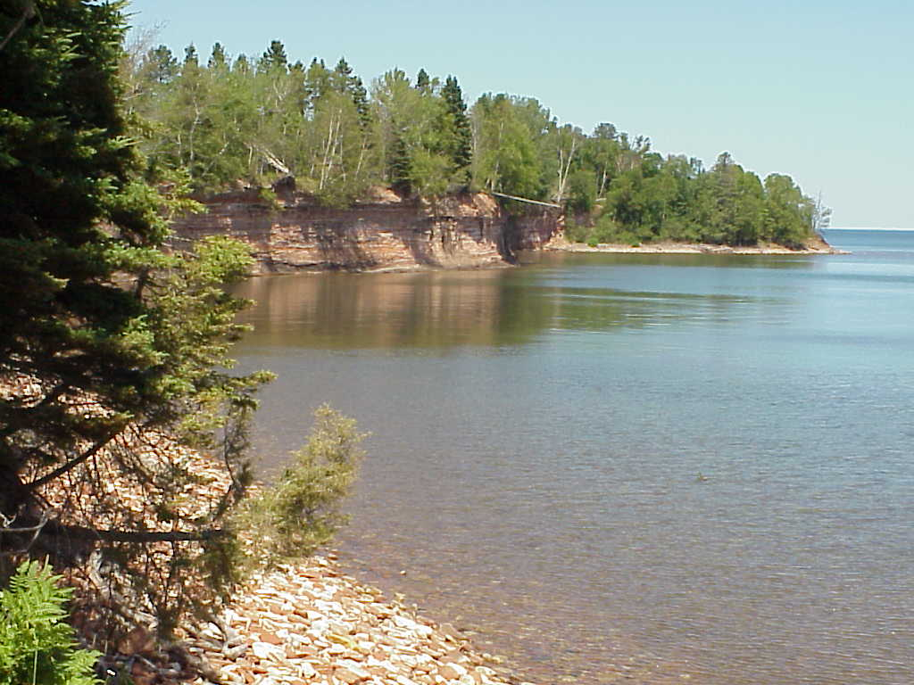
Coasts
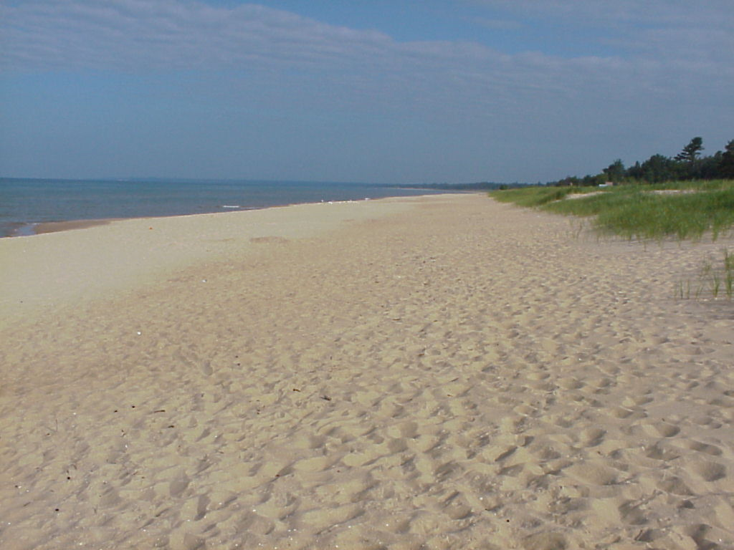
Photo A.
Photo B.

Engage: Are all coasts the same?
Compare the two coasts shown in the photos.
How are the two coasts similar?
How are the two coasts different?
Describe any differences you see.
Which one is more resistant to erosion? Explain your answer.
How would a material’s resistance to erosion maintain a coastline?

Explore:
1. Sand Movement along the Shoreline

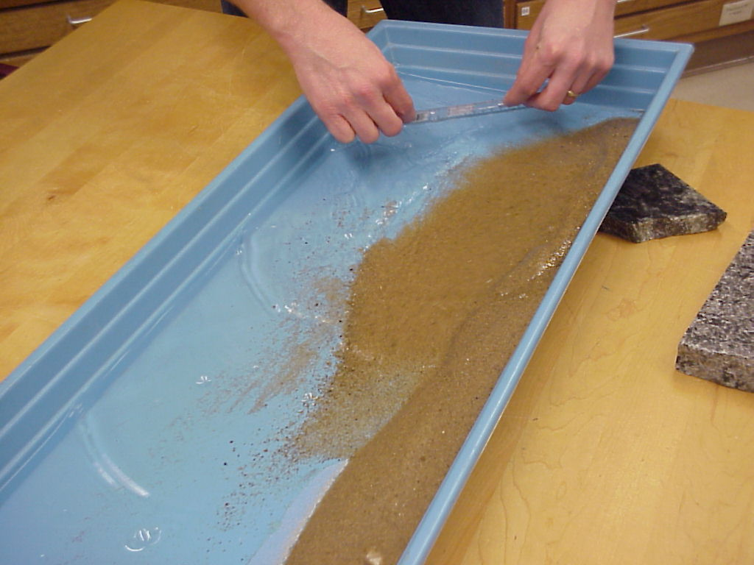
Use a stream table to explore the influence of waves on the coastline.

1. Fill half of the tray with about an inch of sand. Fill the other half with water. Using a rectangle of plastic or push the water up the sandy beach at an angle of about 45°.
a. Write a short description of the motion of the individual sand grains as the waves push them up the beach and then as the waves wash back down the beach.
b. On the diagram below, draw arrows to indicate the motion of the waves and sand.
c. Increase the amount of force used to make waves. How does this change the movement of the sand?
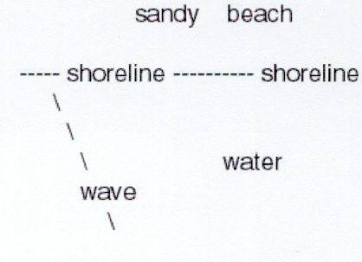
d. What factors influence how sand moves on the beach?

2. Common Landforms along the Coast
a. Sand Dunes
Use dry sand and a hair dryer to explore how wind forms sand dunes.
1. Spread a layer of sand about one inch thick across part of the tray.
a. With a dryer on the low setting, move it towards the sand until grains begin to move. Describe what you see.
b. Repeat the experiment with the dryer on the high setting.
c. Can you see individual grains move? Describe their motion.
d. Experiment with drier to see if you can duplicate any of the shapes shown in the figure below. Under what conditions can
you make these different types of dunes?

2. Start again with a uniform layer of sand. This time use two hair dryers that blow at about 90° to each other.
a. Can you make a different type of dune than you did in activity 1?
b. Describe the new dune.
c. How might this type of dune form along the coast or in the desert?
d. Repeat with a higher setting. Does the dune still form? Does it look the same?
e. How do you think the size of the sand grains might influence if a dune forms?

3. Use one dryer. Fill a square of Astroturf with sand until the turf is just buried.
Blow air on the sand until it just begins to move.
a. Does the Astroturf influence the type of dune that forms? Describe the shape of your dune?

b. Making Tombolos
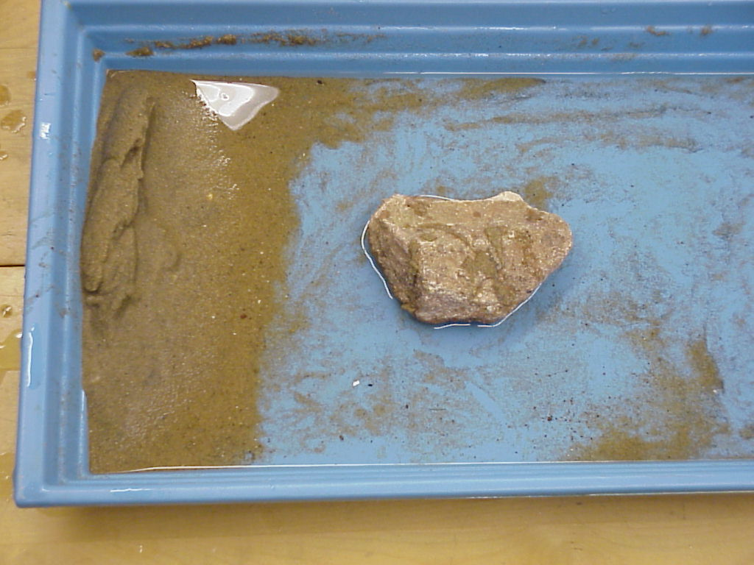
Place a ridge of sand (representing a beach) at on end of the pan. Place a large rock (representing a rocky island) out in front of the sand. Send water waves from the other side of the pan towards the rock.

a. What happens as the waves hit the rocky headland?
b. Where is the maximum erosion on the ridge of sand?
c. Where is the minimum erosion on the ridge of sand?
d. Describe how the shape of the beach changes over time.
Be patient. This explore can take 5-10 minutes.
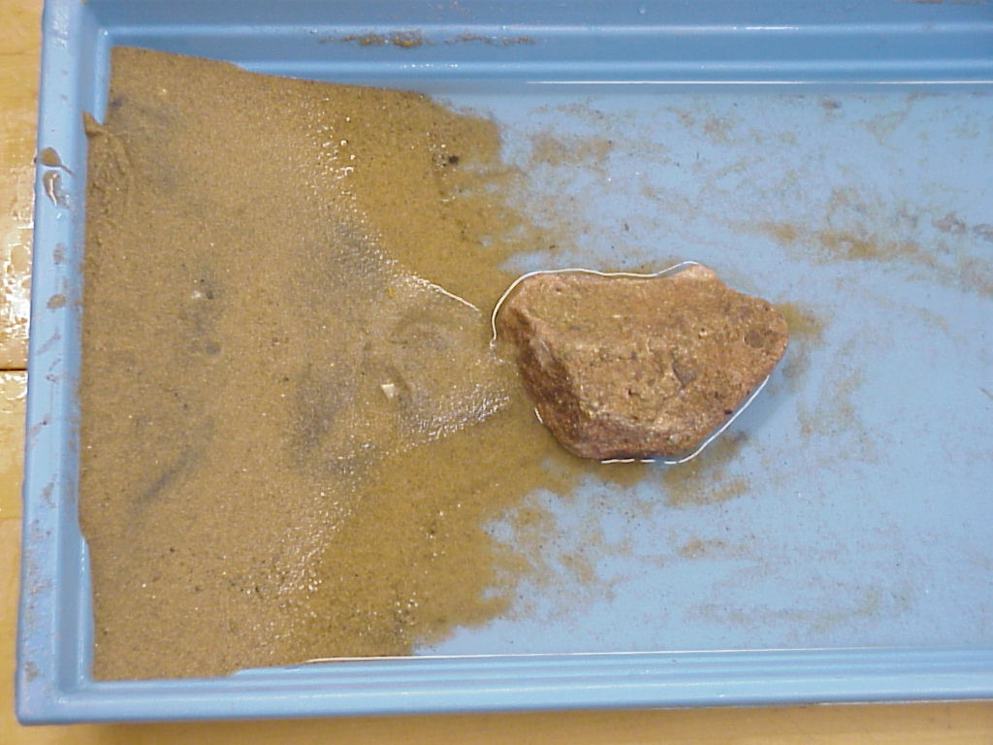
c. Making Spits and Baymouth Bars
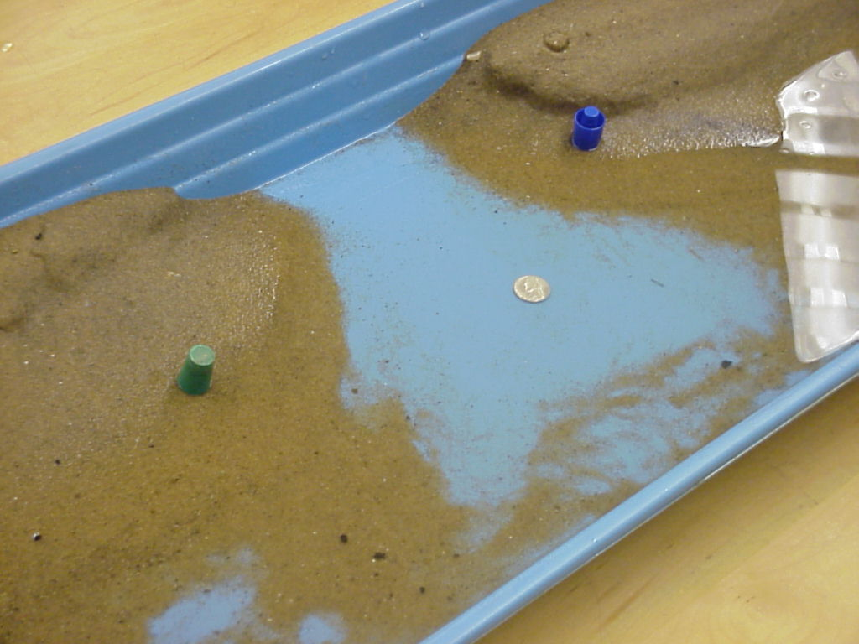

As the glaciers retreated they left many embayments along the shores of the early Great Lakes. Saginaw Bay on the east side of the lower peninsula would by an example of a large bay. Smaller bays are common along the coast. As sediment moves sideways along beaches it must cross these bays. In some places the beach extends across the bay, making a new lake out of the embayment.

The picture above shows an embayment between two sand coasts. The green and blue caps mark the shoreline. A nickel is shown for scale. Make a similar model in your pan. Send waves at an angle towards one beach.

1. Which direction does the sand move?
2. What happens to the sand as it starts to cross the embayment?
3. Continue making waves until the sand closes off the embayment.

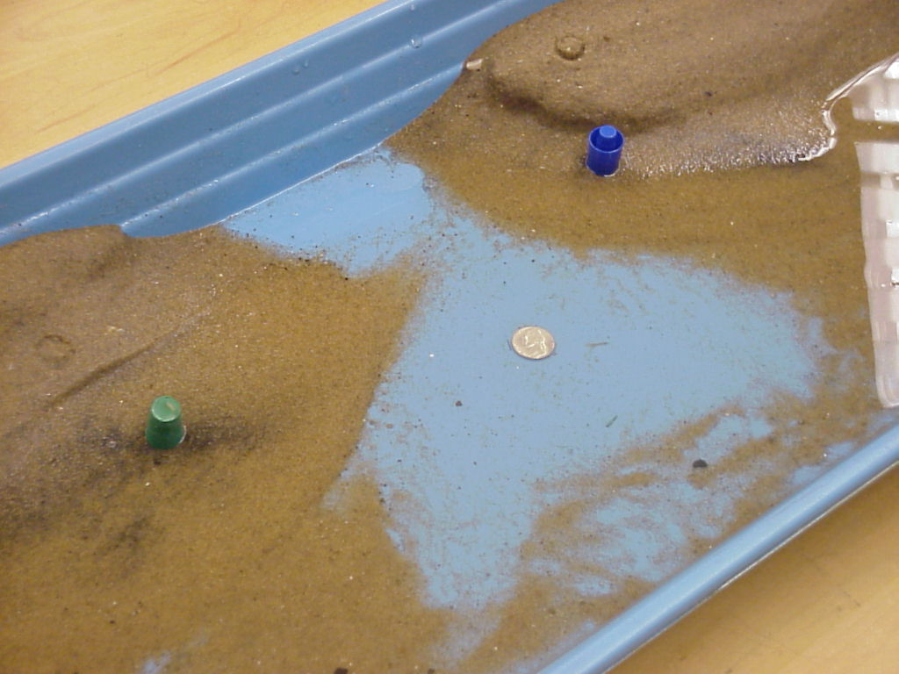

c. Making Deltas
deltas in pan of water

e. Making Sea Stacks and Arches
sea stacks and arches? Erosion of a headland made of?

- erosion (rates)
ask Bill?
Before/after photos

Explain:
Beaches
Beaches and sand dunes are common landforms along the coastlines of the Great Lakes. Beaches are “rivers of sand” that are constantly moving sand in the direction of nearshore currents. Waves wash the sand grains up the beach at an angle until the waves loose their energy. Gravity then pulls the water and sand straight down the beach. This constant motion causes sand to move down the shoreline.

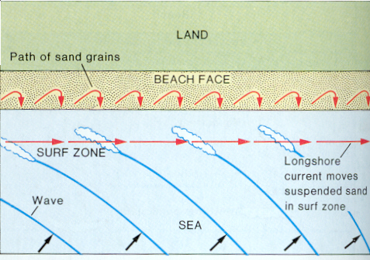
Beaches need a constant source of sand or they will erode away. Manmade structures can interrupt the movement of sand.

Dunes
Sand is transported by a series of short hops in the down-wind direction. This process is called saltation. As the grains skip down wind they impact grains as they land.

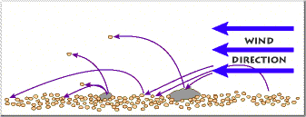
Diagram courtesy of the U.S. Geological Survey.

The impact acts like the collision of two pool balls and sends enough energy into the sand grain that it flies into the air and move downwind.
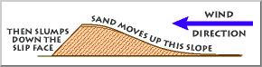
Dunes are ridges or hills made of loose sand. A dune forms as sand piles up on a surface. The wind transports the sand up the long face of the dune.
Diagram courtesy of the U.S. Geological Survey.

The sand reaches the top of the dune and then gravity pulls the grains down the steep slope. Over time, the movement of sand causes the dune to migrate in the down-wind direction.

Sand dunes are preserved in some rocks. Their presence is indicated by thin layers of sand called cross-beds.

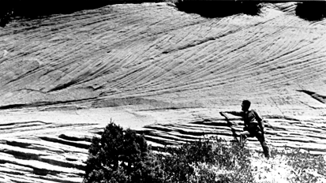
Cross-beds produced by dunes Navajo Sandstone, Zion National Park, Utah. Photo courtesy of the U.S. Geological Survey.

There are four main types of dunes:
Barchan dunes have a crescent shape with the tips pointing down wind. They form when the wind is from one direction.

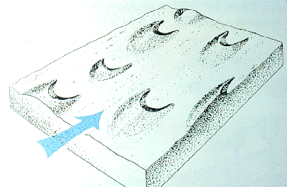
Barchan dunes. Diagram courtesy of the U.S. Geological Survey.

Parabolic dunes are also crescent shaped but their tips pointing into the wind. These
dunes form when part of the dune is stabilized by vegetation. They form when the wind is from one direction.

Transverse dunes are long ridges that form perpendicular to the prevailing wind. They result from storm winds that blow 180° from prevailing winds.

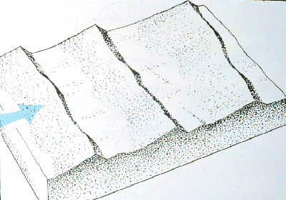
Transverse dunes. Diagram courtesy of the U.S. Geological Survey.

Longitudinal (also called seif) dunes are long ridges that form parallel to the wind. They result from storm winds blowing at an acute angle to the prevailing winds.
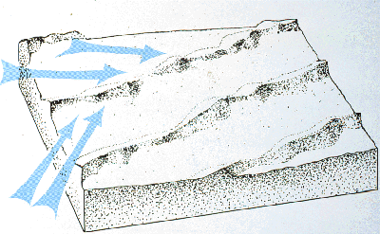
Longitudinal dunes. Diagram courtesy of the U.S. Geological Survey.

The type of dune is a balance between the wind direction, the amount of sand, and the amount of vegetation.
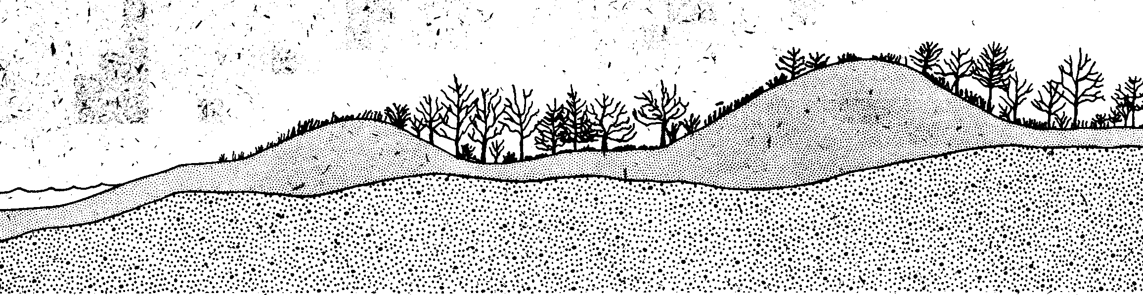
Cross-section of Michigan coastal dunes. From Wilson, S.E., Michigan’s sand dunes, Michigan Department of Natural Resources Geological Survey Division Pamphlet 7, 10 p.

Most sand dunes in Michigan form as long linear ridges parallel to the shore of Lake Michigan. Another set of dunes formed inland. Close to the lake, a set of lower dunes (30-50 feet tall) hugs the shoreline. Adjacent to these low dunes are high dunes that are over 100 feet in height. Some of the high dunes grew on top of older glacial materials. Sleeping Bear dunes and Warren dunes are examples of high dunes.

Spits
A spit is an elongate ridge of sand that projects from the land into the mouth of an adjacent bay.

Tombolos
A tombolo is a ridge of sand that connects an island to the mainland or another island.

Deltas
A delta is an accumulation of sediment formed where a stream enters a lake or an ocean.

Baymouth Bars
A baymouth bar is a sandbar that completely crosses a bay, sealing it off from the main body of water.

Making Sea Stacks and Arches
A sea stack is an isolated mass of rock standing just offshore, produced by wave erosion of a headland.

A sea arch is an arch formed by wave erosion when caves on opposite sides of a headland unite.

Apply: Recognizing Coastal Landforms
1. Where Is the Sand Going?
Man-made structures are added to many shorelines. These structures disrupt the natural flow of sand down the beach. A groin is a structure perpendicular to the beach. It is designed to catch sand. On the diagram below, where would sand be eroded and where would it be captured?
sandy beach
<---- direction of sand movement
--------shoreline -----------------------------X---------------------------------shoreline ----------
X /
X /
X / waves
groin /

2. Recognizing Direction of Sand Transport
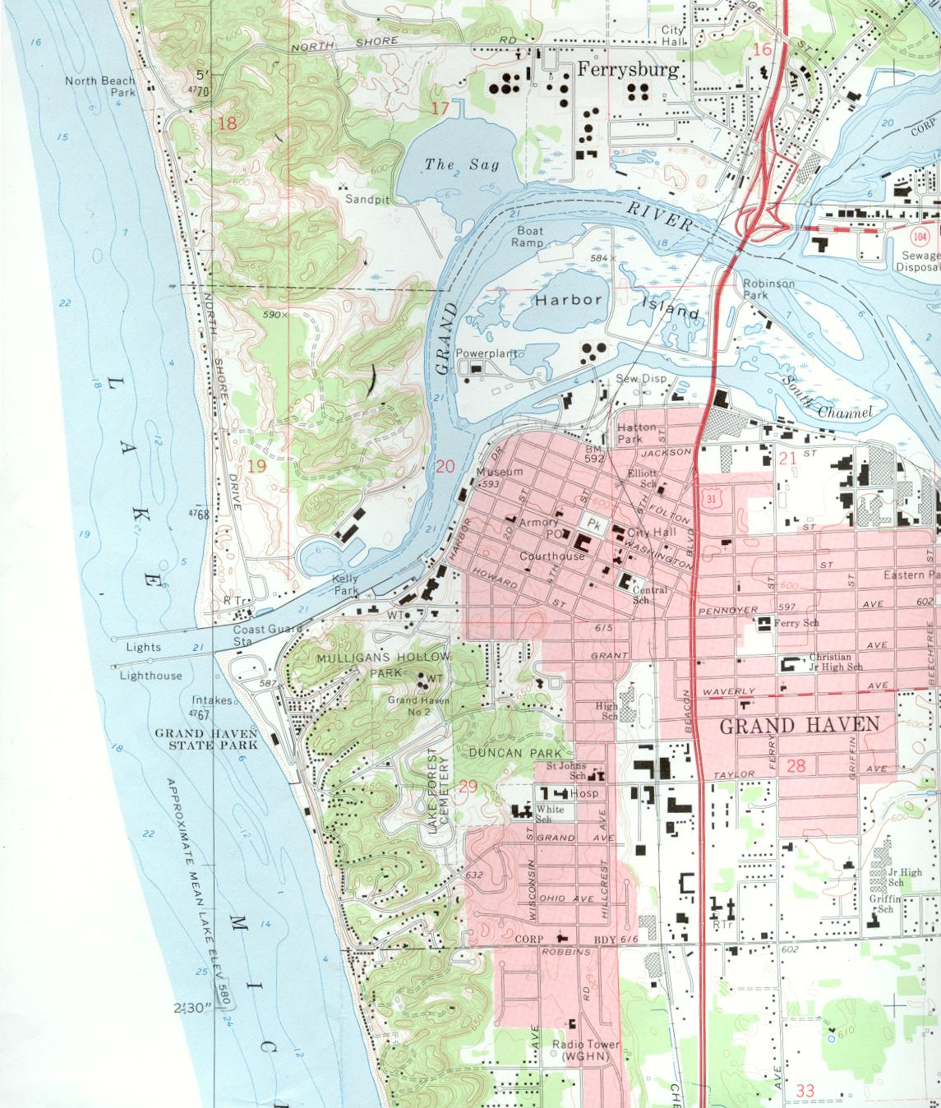
The Grand River discharges into Lake Michigan at the city of Grand Haven. To make sure that the sand migrating along the beaches does not close off the river mouth two barriers (called jetties) have been extended offshore. These barriers disrupt the flow of sand along the beach. This map shows the beaches just north and south of the river.

a. Based on the amount of sand on the beaches, which way is the sand moving?
b. Which beach (north or south) is losing sand due to human interference.

3. Recognizing Coastal Landforms
These map reading exercises ask you to apply what you have learned in Explore and Explain.

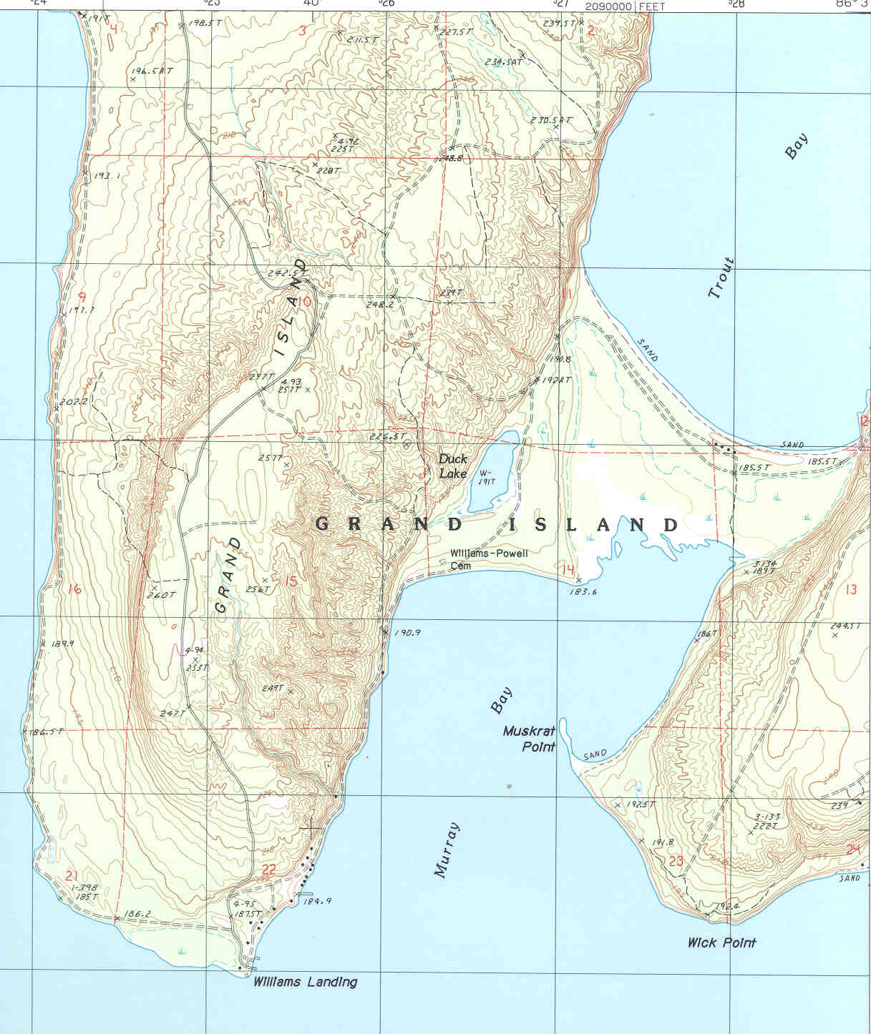
a. Feature 1: Grand Island, north of Munising, Upper Peninsula, Lake Superior
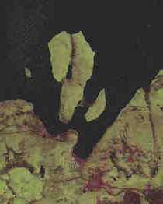
Grand Island is made of two smaller islands joined by a sandy flat area.
What is the landform and origin on the sandy flat area.
b. Feature 2: Sand Bay, near L’Anse, Upper Peninsula, Lake Superior
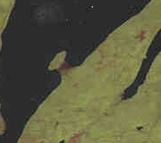
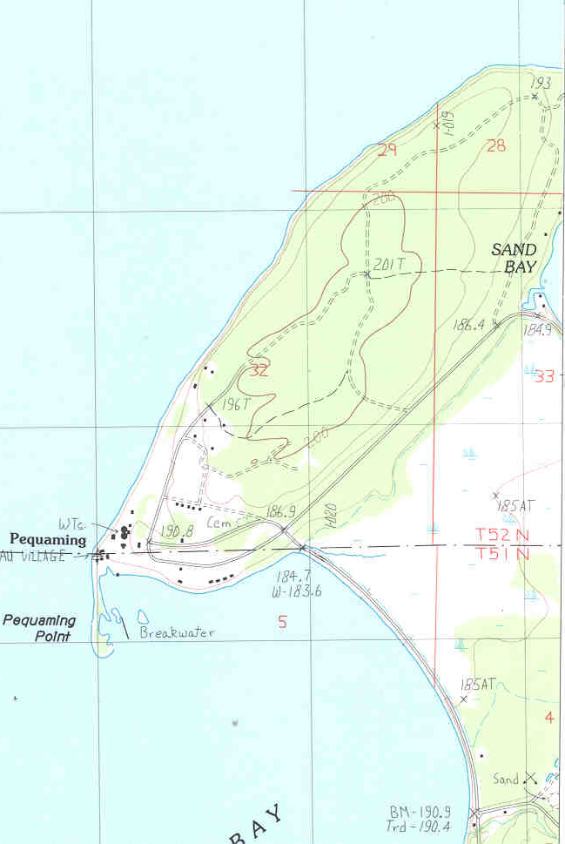
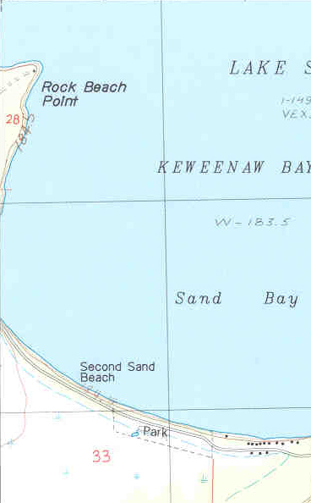

The town of Pequaming sits on a headland west of the Abbaye Peninsula.
A low flat area of sand separates the island from the peninsula.
What is this sandy landform and what is its origin?

c. Making Deltas
deltas in pan of water
delta at Lake St. Claire; need names of topos

d. Making Baymouth Bars

e. Making Sea Stacks and Arches
sea stacks and archs at Castle Rock (1 topo) and Mackinac Island (4 quads)

3. determine the rate of erosion?? Ask the state?

spit at Tawas Point;

Inquire Further:
1. Should sand dunes be mined?
2. Landslides at Sleeping Bear Dunes.
3. Lake levels.

1. Plan a school or family visit to P.J. Hoffmaster State Park to watch the interaction of wind, waves, and dunes.

2. Sleeping Bear Dunes National Lakeshore is named for a Chippewa Indian legend. A brief description of the legend is available online. Better yet, read Gijsbert Van Frankenhuyzen and Kathy-Jo Wargin’s The Legend of Sleeping Bear. How
does the legend compare with the modern-day geology of the park?

3. Silver Lake State Park, north of Muskegon, features sand dunes. Preserve the Dunes, Inc calls for an end to mining of sand from coastal dunes. What are some different ways sand dunes are used? How do you think coastal dunes should be used and why?

4. Many national parks feature sand dunes. Visit some of these parks to see what types of dunes they have and compare them to the dunes in Michigan.

5. During the time that dinosaurs roamed the Earth deserts covered much of what is now the western United States. Deserts of the Mesozoic describes this ancient dunes.

Geologic History

Engage:

Explore:
interpretation of photographs illustrating superposition,
original horizontality, and cross-cutting relationships;
interpretation of simple cross-sections

Big Erics: p. 274 of Centennial Volume

Explain:

Add unconformities

Apply: interpret cross-section of your county

Inquire Further:

1. simplified cross-section
Pc mountain building
← unconformity (Big Eric’s)
Keweenawan basalts
← unconformity (xxx)
Pz basin
← unconformity ()
Quaternary glacial deposits

Ancient Life
Engage: Life Changes (done, see Mike’s Geologic History)

Explore:
1. Charting Life on Earth
2. Stromatolites (Lindberg quarry), photos
- match photos (see CD Rom) to drawings
x. Quaternary extinctions: mammals

Explain:

Pc Stromatolites
all Paleozoic fossils in Michigan – Michigan publication or lab manuals
Quaternary mammals

Apply:
Identify Paleozoic fossils in Michigan
Put in stratigraphic order

Inquire Further:
What caused Quaternary extinctions?

Climate
Engage: Photos of Marquette and Detroit in Spring when snow is gone in Detroit, but not Marquette???

Explore:
- Snowfall in Michigan p. 119
For the following questions use the Average Seasonal Snowfall map on the next page.
a. Is the seasonal snowfall across Michigan the same everywhere?
b. Describe any patterns?
c. Is the seasonal snowfall uniform north-south?
d. Is the seasonal snowfall uniform east-west?
e. What area(s) in the Upper Peninsula received the greatest amount of snowfall?
f. What area(s) in the Lower Peninsula received the greatest amount of snowfall?

2. Graphing Climate Data for Marquette
On the graph paper provided plot the data below.

Month | Average  Monthly Temperature,  °F | Average  Monthly  Temperature,  °C | Average  Monthly  Precipitation,  inches | Average  Monthly  Precipitation,  cm
January | 11.9 |  | 2.17
February | 14.0 |  | 1.73
March | 23.6 |  | 2.77
April | 37.3 |  | 2.64
May | 50.2 |  | 3.03
June | 59.2 |  | 3.48
July | 65.1 |  | 2.88
August | 62.5 |  | 3.41
September | 54.0 |  | 4.08
October | 43.6 |  | 3.61
November | 30.1 |  | 2.89
December | 17.3 |  | 2.61
Convert to C and cm

Insert p. 493 of Tarbuck & L

a. What is the average temperature during the coldest month?
b. What is the average temperature during the warmest month?
c. Is the wettest summer month have 1x, 5x, 10x, 20x, or 25x (circle your answer) more precipitation than the driest winter month?
d. Is the driest summer month have 1x, 3x, 9x, or 12x (circle your answer) more precipitation than the wettest winter month?
e. Does the temperature in Michigan ever exceed 22 °C?
f. Does the temperature in Michigan ever exceed 10 °C for a four month period?

- lake effect at Marquette
How does the distribution of areas with high snowfall amounts correspond to topography?
- north – south temp variation: use January and June, patterns, compare/contrast

Explain:
- physics of lake effect – specific heat of water
- leeward vs windward shores, prevailing winds

Apply:
- lake affect at Muskegon or Grand Haven, contrast to Detroit

2. Construct Your Local Climatic Diagram
Visit the National Weather Service climatology website (see http://www.crh.noaa.gov/climatology.html) and select the city neatest your school. Complete the table below.

Month | Average  Monthly Temperature,  °F | Average  Monthly  Temperature,  °C | Average  Monthly  Precipitation,  inches | Average  Monthly  Precipitation,  cm
January
February
March
April
May
June
July
August
September
October
November
December
Convert to C and cm

Inquire Further:
1. How Big is the Lake Effect?
During the first Engage activity you looked at the influence of the Great Lakes on the snowfall of Michigan. What data would you need to measure the influence of Lake Superior or Lake Michigan on the amount of lake-effect snowfall in Michigan? Where would you find this data? Outline the steps you would take.

2. Snow and the Economy
Does snowfall influence local economy? Look at the map from the first Engage activity. What businesses benefit from this increased snowfall? Michigan Live (http://www.mlive.com/travel/) may be a useful resource.

Miscellaneous:
BIFS and the atmosphere
Copper ore for Economic
Sand and gravel for Economic
Vegetation and Geology

