Using Extreme Weather Events to Quantify the Hydrologic Cycle
By Steve Mattox and Kimmy Jenerou
Steve Mattox
Professor of Geology
133 Padnos Hall of Science
Grand Valley State University
Allendale, MI 49401-9403
Phone: (616) 331-3734
Fax: (616) 331-3740
Email: mattoxs@gvsu.edu

Science Teacher
School of Health Sciences at Central Campus
(616) 819-6834
jenerouk@grps.org

30 Words
We model how students can use the remnants of a hurricane to track billions of gallons of rainfall to surface water outflow, groundwater levels and evapotranspiration in their watershed.

Extreme weather events provide an opportunity to quantify processes within the hydrologic cycle that are commonly only addressed in vague or qualitative methods. In September of 2008 the remnants of Hurricane Ike tracked over Michigan. Online historical rainfall data from the National Weather Service indicated that up to 7.5 inches of rain fell in some counties. Students calculate the area of their watershed and the volume of rain in their watershed in cubic inches and convert to gallons of water. Larger watersheds, such as the upper Kalamazoo River, received more than 130 billion gallons of water in less than 2.5 days. River discharge data was obtained for the event on the U.S. Geological Survey’s Real-Time Water Data website. Students calculate the volume of water that leaves the watershed by converting cubic feet per second to gallons per day. For the Kalamazoo River about 50 billion gallons of water left the watershed in the following 35 days, about 38 % of the rainfall. Real-time data for the groundwater response is rare but U.S. Geological Survey maintains a well that responded to the deluge by rising about 15 inches in 21 days. Other data in west Michigan estimates evapotranspiration accounts for about 30% of the water leaving the watershed. This exercise provides a perspective on the amounts of water available within systems and the amounts used by cities and industry. The exercise can be easily modified to any watershed and use more frequent, modest rainfall.
Balancing the H₂O Budget (in Kalamazoo and Jackson) by Kimmy Jenerou and Steve Mattox
In this activity you will use simple math to take a closer look at the water cycle during a major event, the September 2008 rain and flood. The activity moves through several steps:
How much water was added to the watershed?
Convert the area of the watershed from square miles to square inches.
Calculate the amount of rainfall in inches.
Calculate the volume of rainfall in cubic inches and convert to gallons.

How much water flowed out of the watershed?
Calculate the amount of water flowing down a river and convert to gallons.

Discussion: Is the water cycle balanced?

How much water was added to the watershed?

Let’s look at two watershed in Kalamazoo of different sizes, Portage Creek and the Kalamazoo River. Two tributaries of Portage Creek have areas of 22 mi2 and 1.7 mi2, for a total of 40.7 mi2. The area of the Kalamazoo River watershed above the city of Kalamazoo (as measured at Comstock Park) is 1,010 mi2.

The area of the Grand River watershed above the city of Jackson is 174 mi2.

Convert the area of the watershed from square miles to square inches.
Remember there is 5,280 feet in one mile and 12 inches to one foot.

For the area of Portage Creek in in2,

40.7 mi2 x (5280 ft)2 = 1,134,650,880 ft2 x (12 in)2 = 163,389,726,720 in2, about 163 billion square inches.
1 mi2 1ft2

Calculate the amount of rainfall in inches for Kalamazoo:
Date | Rainfall (inches)
9-12 | 0.74
9-13 | 3.4
9-14 | 3.38
9-15 | 0.02
9-16 | 0
9-17 | 0
Total = | 7.52

Calculate the volume of rainfall in cubic inches and convert to gallons.

163,389,726,720 in2 x 7.52 in = 1,228,690,744,934 in3, about 1.2 trillion in3 of water.
To convert to gallons, 1 cubic inch = 0.00432900433 US gallons,
1,228,690,744,934 in3 x 0.00432900433 gallons = 5,319,007,531 gallons or 5.3 billion gallons of water
1 in3

For the area of the Grand River in Jackson in in2,

174 mi2 x (5280 ft)2 = 4,850,841,600 ft2 x (12 in)2 = 698,521,190,400 in2, about 698 billion square inches.
1 mi2 1ft2

Calculate the amount of rainfall in inches for Jackson:
Date | Rainfall (inches)
9-12 | 0.5
9-13 | 0.75
9-14 | 3
9-15 | 2.5
9-16 | 0
9-17 | 0
9-18 | 0
Total = | 6.75

Calculate the volume of rainfall in cubic inches and convert to gallons.

698,521,190,400 in2 x 6.75 in = 4,715,018,035,200 in3, about 4.7 trillion in3 of water.
To convert to gallons, 1 cubic inch = 0.00432900433 US gallons,
4,715,018,035,200 in3 x 0.00432900433 gallons = 20,411,333,490 gallons or 20.4 billion gallons of water
1 in3
For the area of the Kalamazoo River in Kalamazoo in in2,

1,010 mi2 x (5280 ft)2 = 28,157,184,000 ft2 x (12 in)2 = 4.054,634,496,000 in2, about 4 trillion square in.
1 mi2 1ft2

Calculate the amount of rainfall in inches for Kalamazoo:
Date | Rainfall (inches)
9-12 | 0.74
9-13 | 3.4
9-14 | 3.38
9-15 | 0.02
9-16 | 0
9-17 | 0
Total = | 7.52

Calculate the volume of rainfall in cubic inches and convert to gallons.

4.054,634,496,000 in2 x 7.52 in = 30,490,851,409,920 in3, about 30.5 trillion in3 of water.
To convert to gallons, 1 cubic inch = 0.00432900433 US gallons,
30,490,851,409,920 in3 x 0.00432900433 gallons = 131,995,027,778 gallons or 131.9 billion gallons of water
1 in3

To summarize:

 | Area (mi2) | Rainfall (in) | Volume (gallons)
Portage Creek | 40.7 | 7.52 | 5.3 billion
Jackson | 174 | 6.75 | 20.4 billion
Kalamazoo | 1,010 | 7.52 | 131.9 billion

How much water flowed out of the watershed?
Calculate the amount of water flowing down a river and convert to gallons.

For the volume of water flowing through the Kalamazoo River in Kalamazoo in cubic feet per second can be estimated using datafrom U.S.G.S. real-time water data for the station at Comstock Park (USGS 04106000). The curve is shown below.
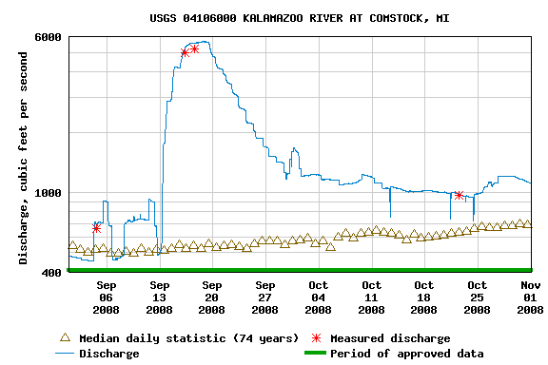

Students must estimate an average value for each week and then convert ft3/s to ft3/d.

The conversion is:

1 ft3 x 60 s x 60 min x 24 hr x 7 days = 604,800 ft3
s 1 min 1 hr 1 d week

Estimated, from the hydrograph above, the weekly average discharge values in ft3/s and then convert to gallons, 1 cubic foot = 7.48 US gallons:

Week of | Discharge, ft3/s, Kalamazoo River | Volume of water per week, ft3/week | Gallons of water per week
Sept 13-20 | 5,000 | 3,024,000,000 | 22,619,520,000
20-27 | 2,500 | 1,512,000,000 | 11,309,760,000
27-Oct 4 | 1,500 | 907,200,000 | 6,785,856,000
Oct 4-11 | 1,100 | 665,280,000 | 4,976,294,400
11-18 | 1.050 | 635,040,000 | 4,750,099,200
18-25 | 1,000 | 604,800,000 | 4,523,904,000
 |  |  | 54,965,433,600

What volume of water fell as rainfall to cause the 2008 flood? 131.9 billion gallons.
What volume of water flowed down the Kalamazoo R. to cause the 2008 flood? 54.9 billion gallons.

Describe the duration of the rainfall event relative to the onset and duration of the flooding.
The river started to rise quickly after the rainfall but crested 4-5 days later and stayed high for weeks.

Based on your knowledge of the water cycle do these volumes make sense? Is there extra or missing water? What volume? Where could it be other water be?

Yes, it makes sense that the rainfall is greater than the river outflow. The missing or unaccounted for water, about 75 billion gallons, might still be in the ground or evaporated.

What additional evidence might support your hypotheses for where the water might be?
Look for data about groundwater levels or amounts of evaporation.

The U.S. Geological Survey has real-time data for a water well in northern Indiana, about 45 miles south of Kalamazoo (see Site Number: 414318085200601). The well is in glacial sand and gravel. Data for July through November 2008 is shown below.

Did the depth to groundwater change in response to the September 2008 rainfall event? If so, how much?
Yes, the ground water rose closer to the surface, about 1.25 feet or 15 inches of water was added.

Based on your knowledge of the water cycle do these volumes make sense? Is there extra or missing water? What volume? Where could it be other water be?
Yes, the added rain should add water to the ground water system. The amount of the groundwater rise, 15 inches, is much greater that the ~5 inches of rain in this area.
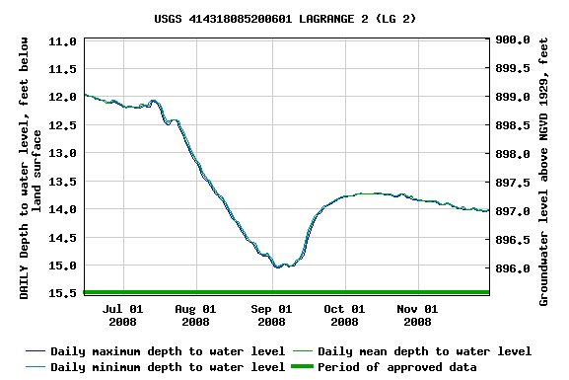

References:

Google Earth Flood Overlay--
https://hazards.fema.gov/femaportal/wps/portal/NFHLWMSkmzdownload
Meteorological Data—
http://water.weather.gov/ahps/
Here you can pull up archived daily average rainfall for a region. It requires a little estimation, but you can see a range of rainfall for each day of the flood event.

Photos of the 2008 flood.
http://www.x98ruhf.net/kalamazoo.htm
Here is monthly climate data for the city of Kalamazoo. From the site, you can also download information which includes precipitation amounts for each day of the flood event.

Gauging Station Data—
http://waterdata.usgs.gov/nwis/dvstat?referred_module=sw&search_site_no=04106300&format=sites_selection_links
Here is the station used for Portage Creek at Kalamazoo. The parameters can be set to view discharge for the flood event.
http://waterdata.usgs.gov/nwis/dvstat?referred_module=sw&search_site_no=04109000&format=sites_selection_links
Here is the station used for the Grand River at Jackson. Same as for Portage Creek, parameters can be set to view discharge for this location as well.

How much water flowed out of the Grand River watershed in Jackson?
Calculate the amount of water flowing down a river and convert to gallons.

For the volume of water flowing through the Grand River in Jackson in cubic feet per second can be estimated using data from U.S.G.S. real-time water data for the station at Comstock Park (USGS 04109000). The curve is shown below.

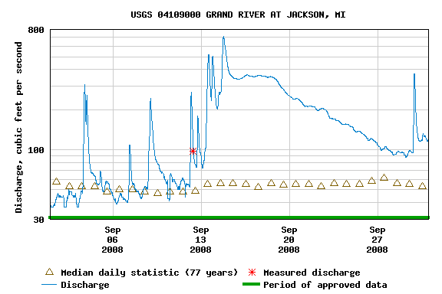

Students must estimate an average value for each week and then convert ft3/s to ft3/d.

The conversion is:

1 ft3 x 60 s x 60 min x 24 hr x 7 days = 604,800 ft3
s 1 min 1 hr 1 d week

Estimated, from the hydrograph above, the weekly average discharge values in ft3/s and then convert to gallons, 1 cubic foot = 7.48 US gallons:

Week of | Discharge, ft3/s | Volume of water per week, ft3/week | Gallons of water per week
Sept 13-20 | 350 | 211,680,000 | 1,583,366,400
20-27 | 175 | 105,840,000 | 791,683,200
 |  | Total | 2,375,049,600

What volume of water fell as rainfall to cause the 2008 flood? 20.4 billion gallons.
What volume of water flowed down the Grand River to cause the 2008 flood? 2.375 billion gallons.

Describe the duration of the rainfall event relative to the onset and duration of the flooding.
The rainfall events of the 13th and 14th show as spikes in discharge. The big rainfall events on the 15th and 16tth led to the flooding and high discharge that lasted almost a week.

Based on your knowledge of the water cycle do these volumes make sense? Is there extra or missing water? What volume? Where could it be other water be?

Yes, it makes sense that the rainfall is greater than the river outflow. The missing or unaccounted for water, about 18 billion gallons, might still be in the ground or evaporated.

What additional evidence might support your hypotheses for where the water might be?
Look for data about groundwater levels or amounts of evaporation. Also look at landscape features, like marshes and lakes that might store more water.

- Calculate daily discharge of each location.
  - Grand River
    - 9/12—115 cfs
      - 9.9 million ft³
    - 9/13—263 cfs
      - 22.7 million ft³
    - 9/14—384 cfs
      - 33.1 million ft³
    - 9/15—362 cfs
      - 31.3 million ft³
    - 9/16—355 cfs
      - 30.7 million ft³
    - 9/17—358 cfs
      - 30.9 million ft³
    - 9/18—349 cfs
      - 30.1 million ft³
  - Portage Creek
    - 9/12—33 cfs
      - 2.8 million ft³
    - 9/13—160 cfs
      - 13.8 million ft³
    - 9/14—307 cfs
      - 26.5 million ft³
    - 9/15—219 cfs
      - 18.9 million ft³
    - 9/16—79 cfs
      - 6.8 million ft³
    - 9/17—50 cfs
      - 4.3 million ft³
    - 9/18—42 cfs
      - 3.6 million ft³
- Compare total discharge to total volume of water that fell on each location.
  - Portage Creek
    - Total discharge: 70.7 million ft³ (530 million gallons)
    - Total volume that fell: 2.8 billion gallons
  - Grand River
    - Total discharge: 188.7 million ft³ (1.4 billion gallons)
    - Total volume that fell: 20 billion gallons

